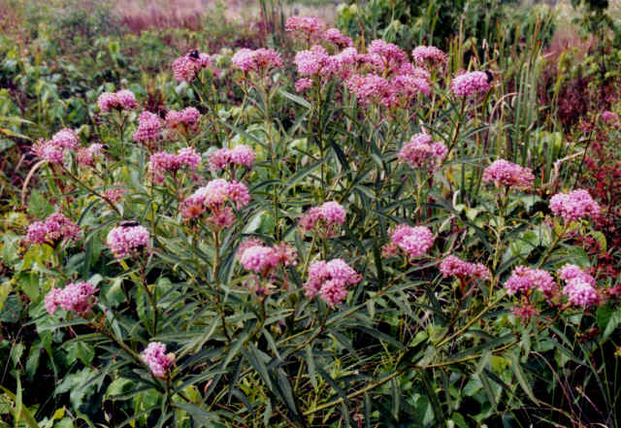  Asclepias incarnata (Swamp Milkweed)  H: 4 feet, July, August | 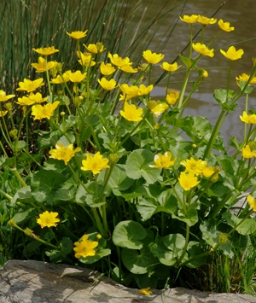  Caltha palustris (Marsh Marigold)  H: 10 to 12 inches, Early spring
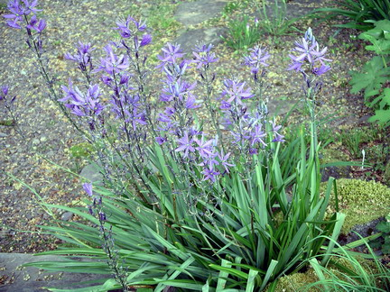  Camassia leichtlinii (Indian Hyacinth)  H: 3 feet, April, May | 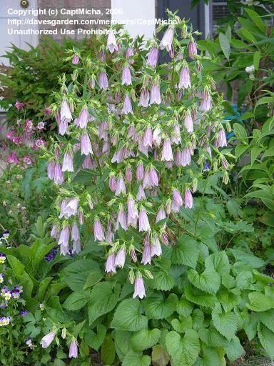  Campanula takesimana (Korean Bellflower) H:1.5 to 2 feet, July, August

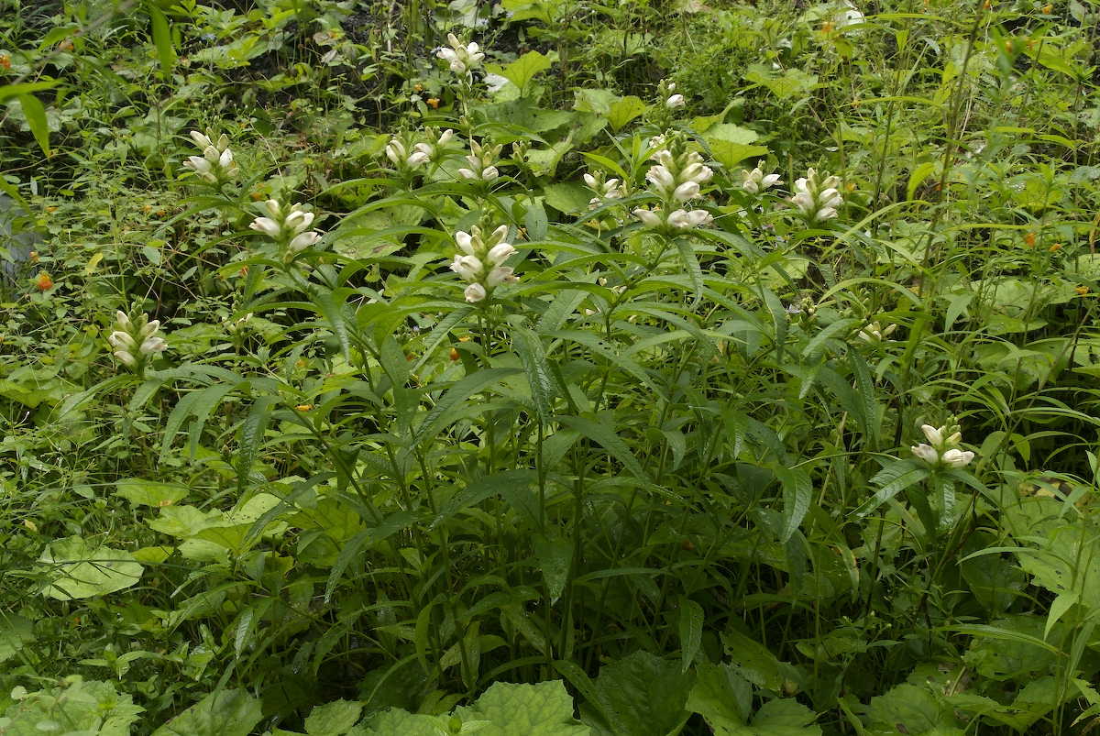  Chelone glabra (White Turtlehead)  H: 2 to 3 feet, August, September | 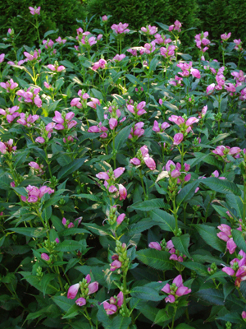  Chelone lyonii (Pink Turtle-Head)  H: 2 to 4 feet, July-September
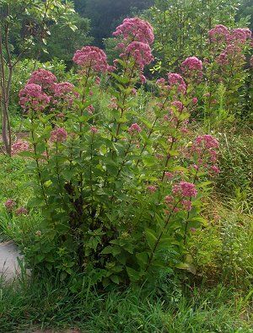  Eupatorium ‘Little Joe’ (Joe Pye Weed)  H: 3 to 4 feet, July-Sept | 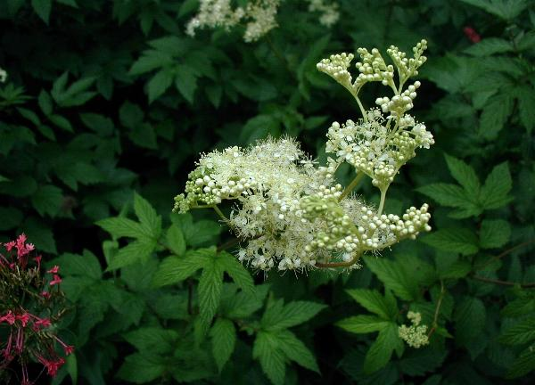  Filipendula ulmaria (Meadowsweet)  H: 3 to 6 feet, June-August

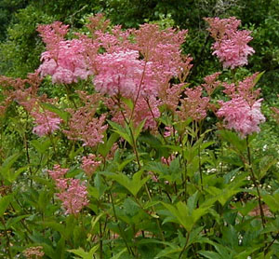  Filipendula rubra (Queen of the Prairie)”  H: 6 to 8 feet, June to August | 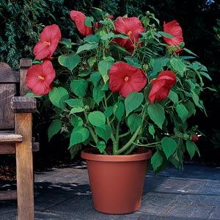  Hibiscus moscheutos ‘Luna Red’(Hardy Hibiscus)  H: 2 to 3 feet, July-September
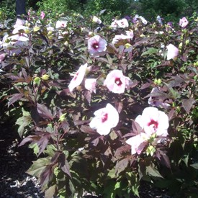  Hibiscus moscheutos ‘Kopper King’ (Hardy Hibiscus)  H: 3 to 4 feet, July - September | 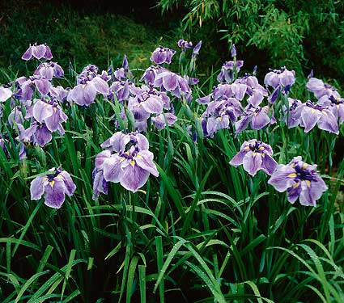  Iris ensata (Japanese Iris)  H: 2 to 4 feet, June, July

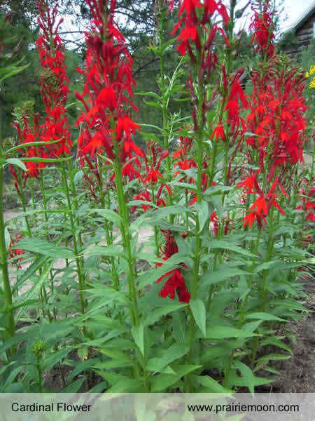  Lobelia cardinalis (Cardinal Flower)  H: 2 to 4 feet, July to September | 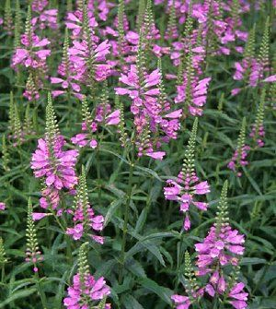  Physostegia virginiana (Obedient Plant)  H: 3 to 4 feet, July-September,  can be aggressive
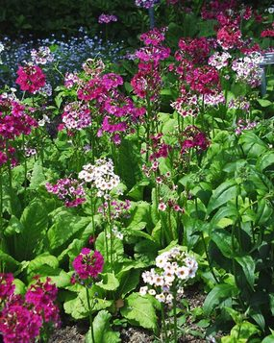  Primula japonica (Japanese Primrose)  H: 12 to 18 inches, Late spring, early summer | 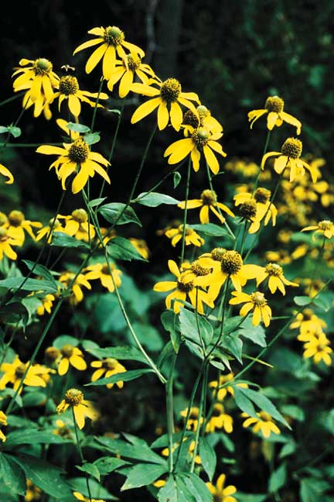  Rudbeckia laciniata (Green Headed Cone flower)  H: 3 to 9 feet, July - September

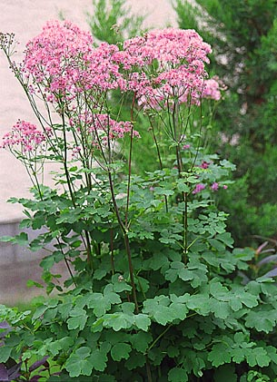  Thalictrum rochebruneanum (Lavender Mist Meadow Rue)  H: 6 to 8 feet, July - September | 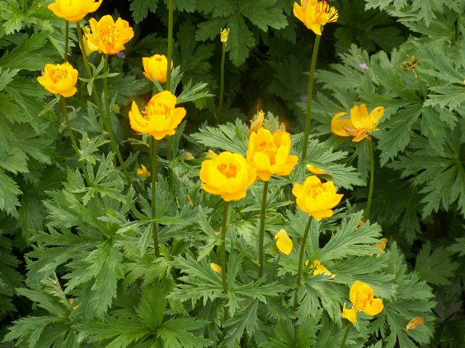  Trollius X cultorum (Globeflower)  H: 2 to 3 feet, May, June
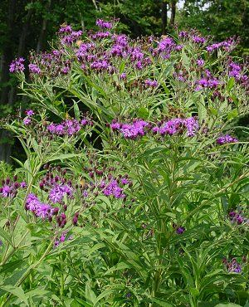  Vernonia noveboracensis (Ironweed)  H: 4 to 6 feet, August, September | 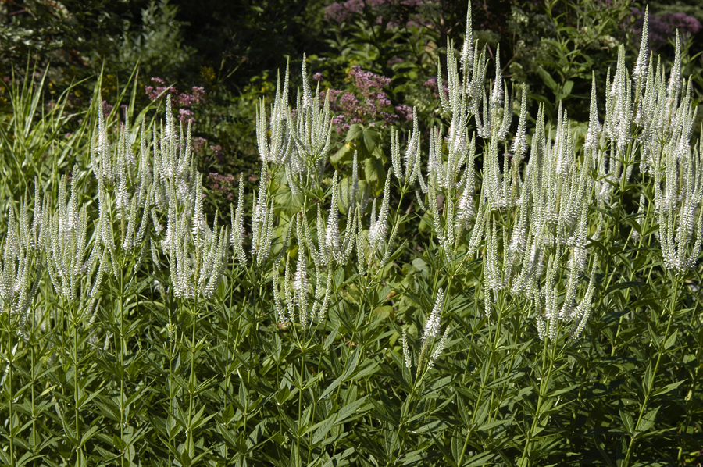  Veronicastrum virginicum (Culver’s Root) 1  H: 4 to 7 feet, June to August

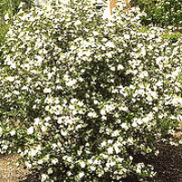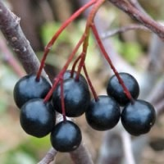  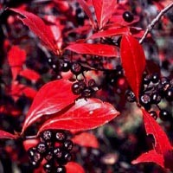  Aronia melanocarpa (Chokeberry)  H: 3 to 6 feet, May, fruit and fall foliage color | 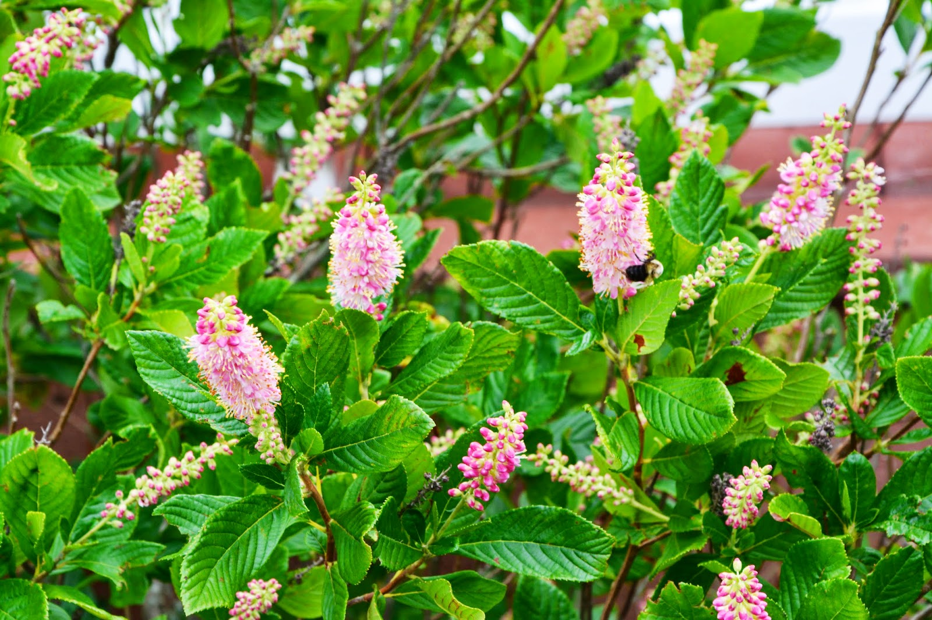  Clethra alnifolia ‘Ruby Spice’ (Summersweet) H: 4 to 6 feet, July – August, fall color
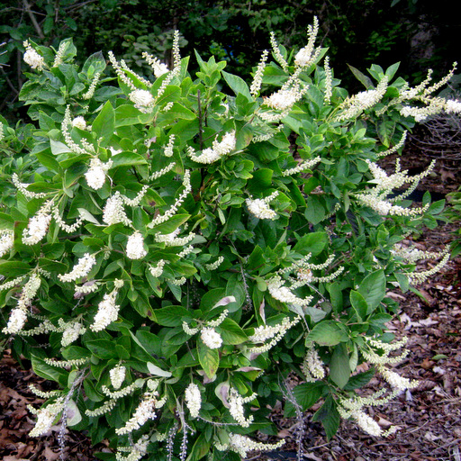  Clethra alnifolia ‘Hummingbird’  H: 2 to 4 feet, July, August, fall color | 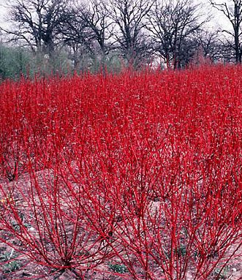  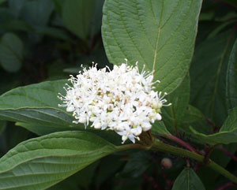  Cornus sericea ‘Baileyi’ (Red Osier Dogwood) H: 6 to 10, May, June, Red stems in winter

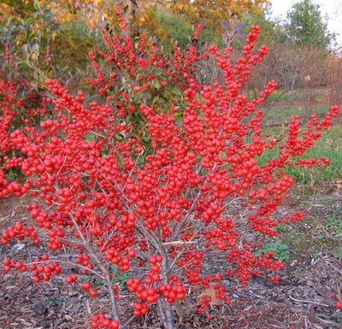  Ilex verticillata ‘Red Sprite’(Winterberry)  H: 3 to 5 feet, red berries late summer, fall and winter. Needs a male for pollination | 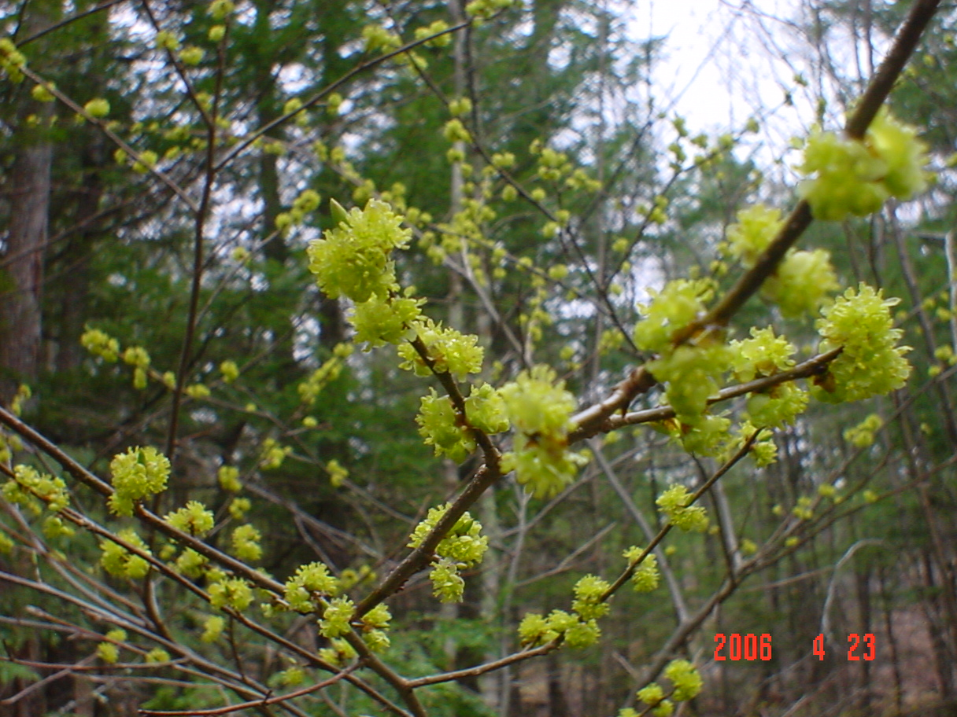  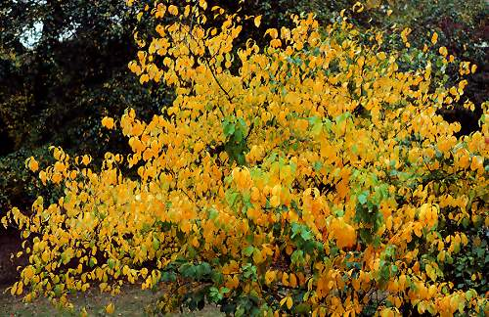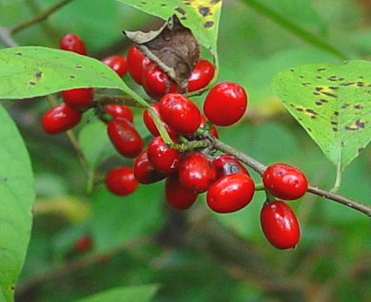  Lindera benzoin (spicebush)  H: 6 to 12 feet, March, fruit, fall color
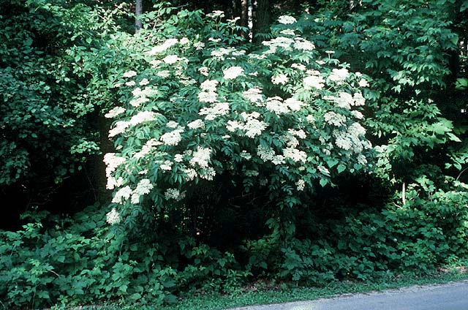
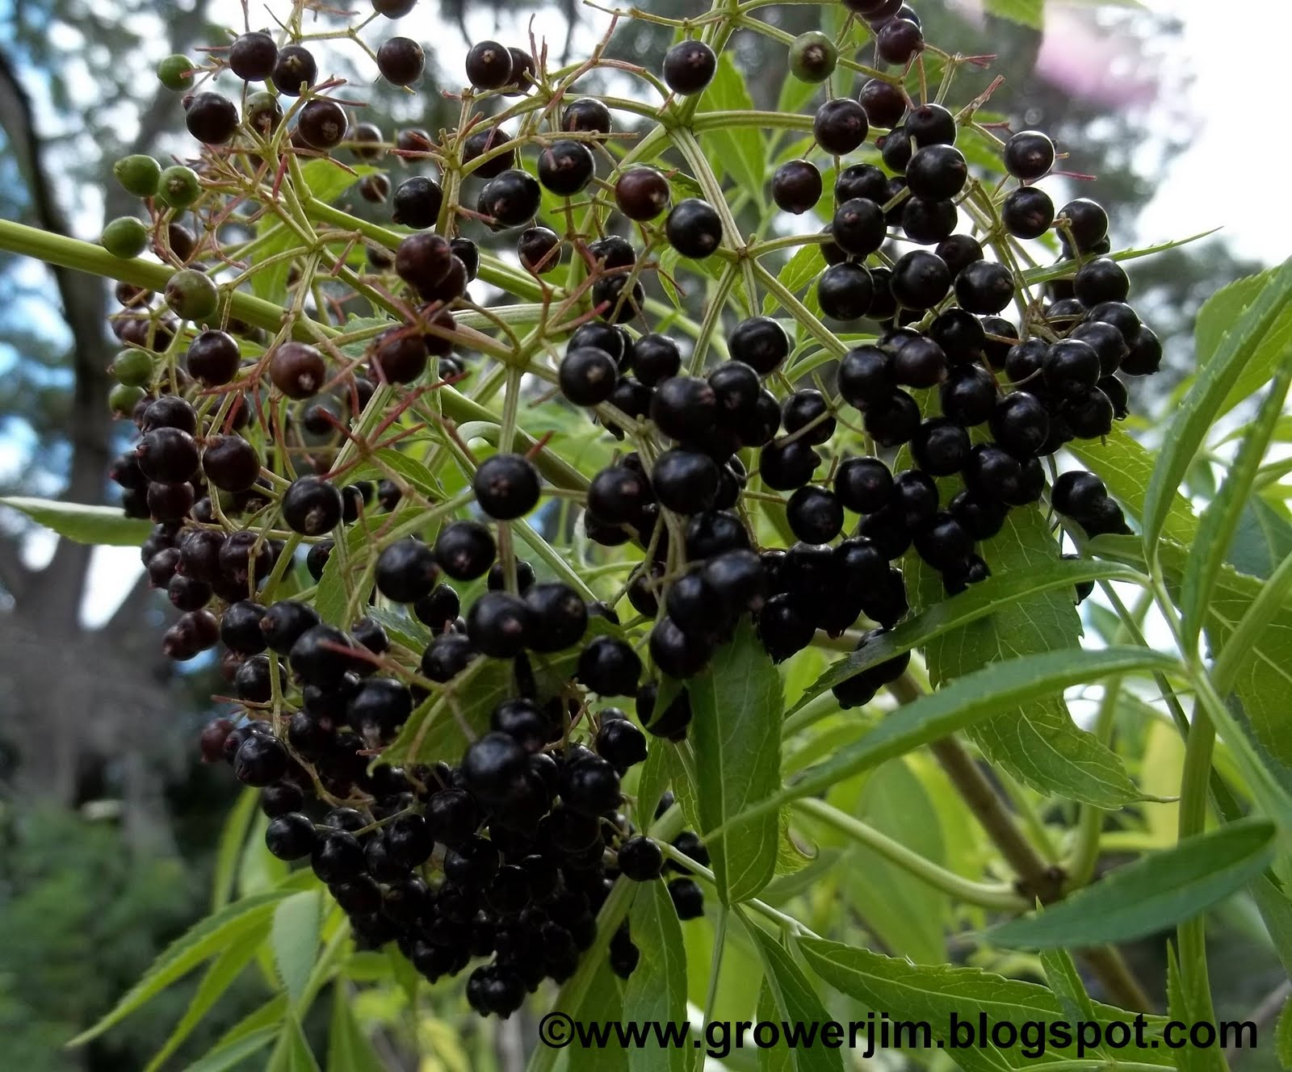
Sambucus canadensis (Elderberry)
H: 5 to 12 feet, June, July, attractive edible fruit

