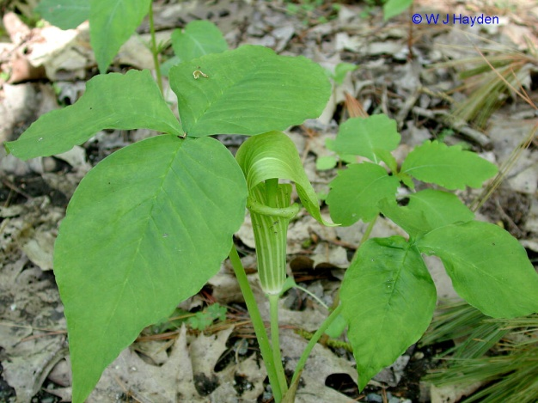  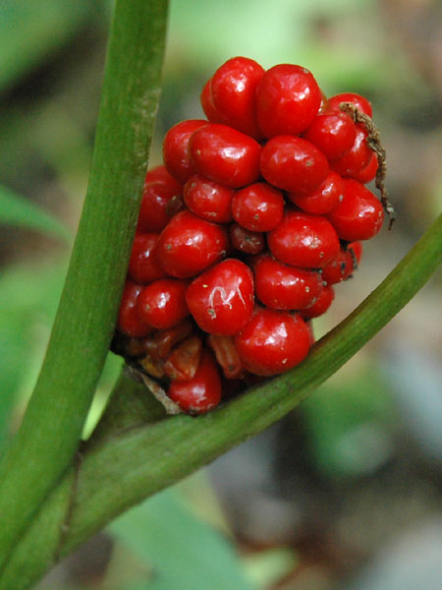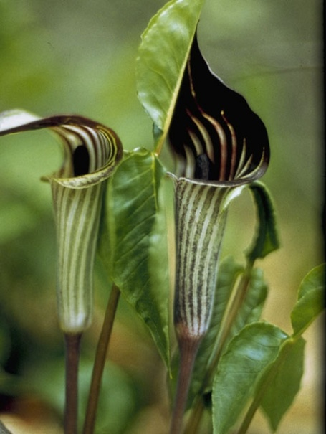  Arisaema triphyllum (Jack in the Pulpit)  H: 1 to 2 feet, April, May, Red berries on mature plants in late summer | 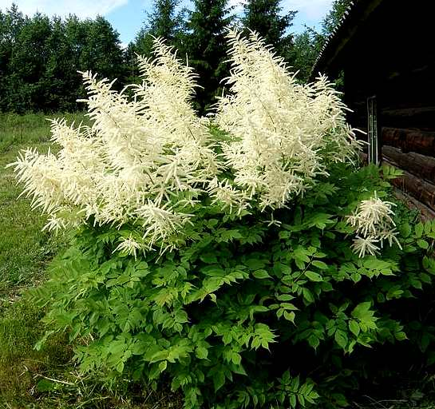  Aruncus dioicus (Goatsbeard)  H: 4 to 6 feet, May,June
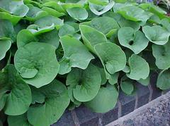  Asarum canadense (Wild Ginger)  H: 0.5 to 1 foot, April, May, Flowers may be hidden | 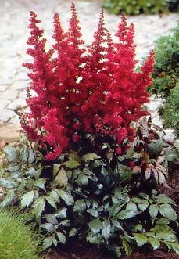  Astilbe ‘Fanal’  H: 1.5 feet, July

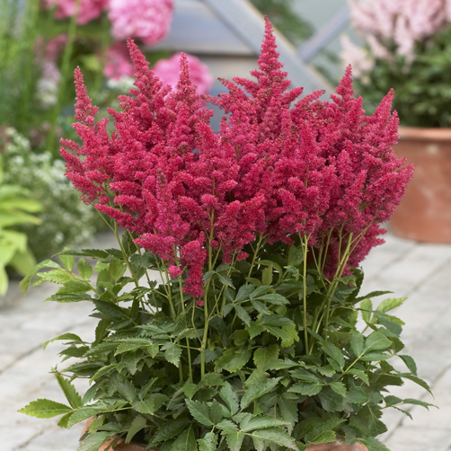  Astilbe ‘Fireberry’  H: 16 inches, June, July | 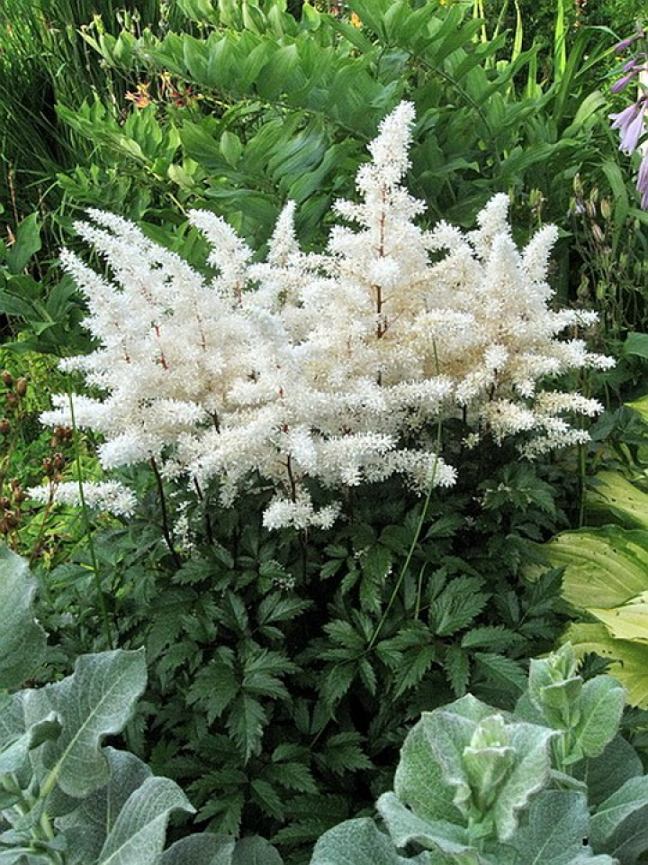  Astilbe ‘Rock and Roll’  H: 20 inches, July
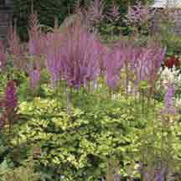  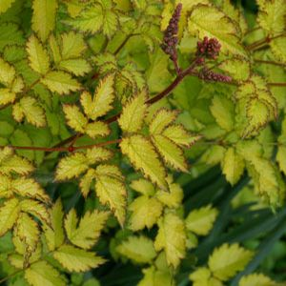  Astilbe ‘Color Flash Lime’  H: 22 inches, July | 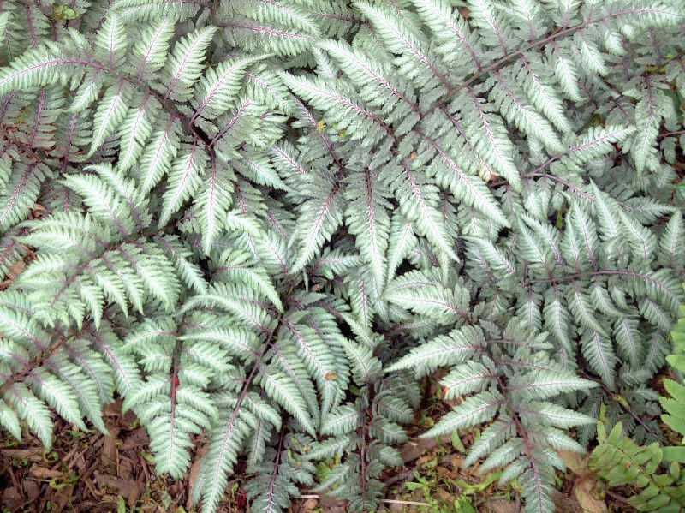  Athyrium niponicum var. pictum(Japanese Painted Fern)  H: 1 to 1.5 feet

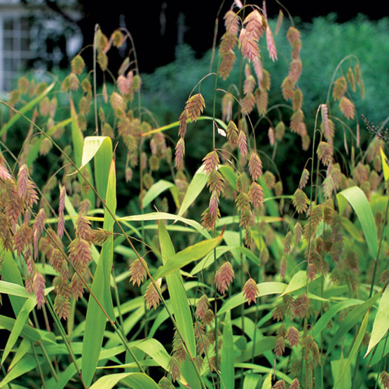  Chasmanthium latifolium (Northern Sea Oats) H: 2 to 5 feet, August, September | 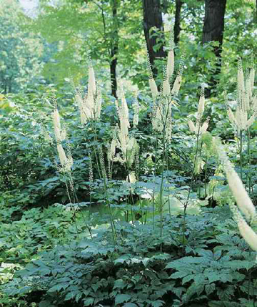  Actaea racemosa (Bugbane)  H: 4 to 6 feet, June, July
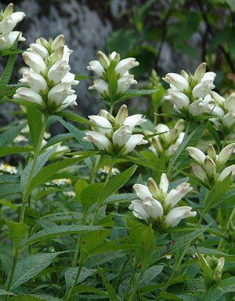  Chelone glabra (Turtlehead)  H: 2 to 3 feet, July,August | 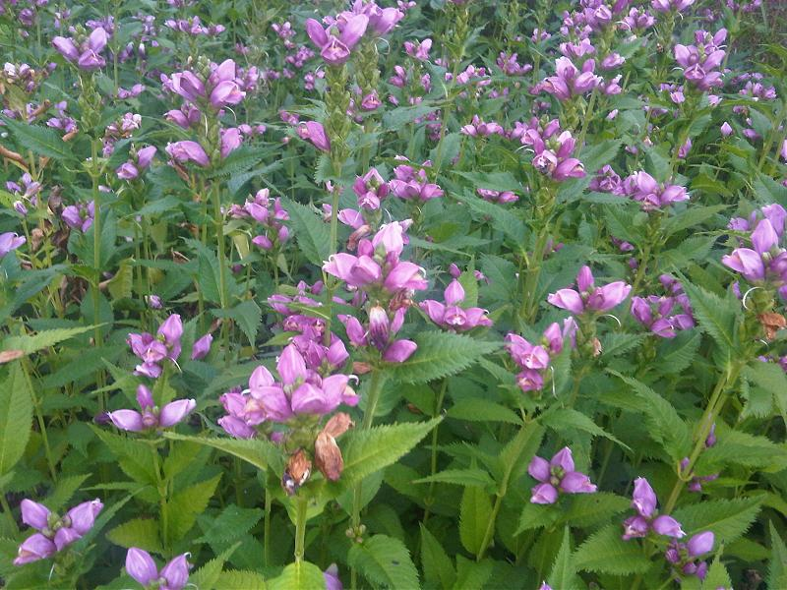  Chelone obliqua (Rose Turtlehead)  H: 2 to 3 feet, August, September

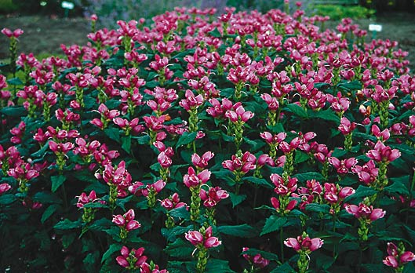  Chelone lyonii ‘Hot Lips’ (Pink Turtlehead)  H: 2 to 3 feet, Late July,August | 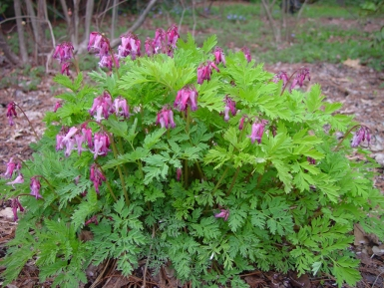  Dicentra eximia (Fringed Bleeding Heart)  H: 1 to 1.5 feet, June, July
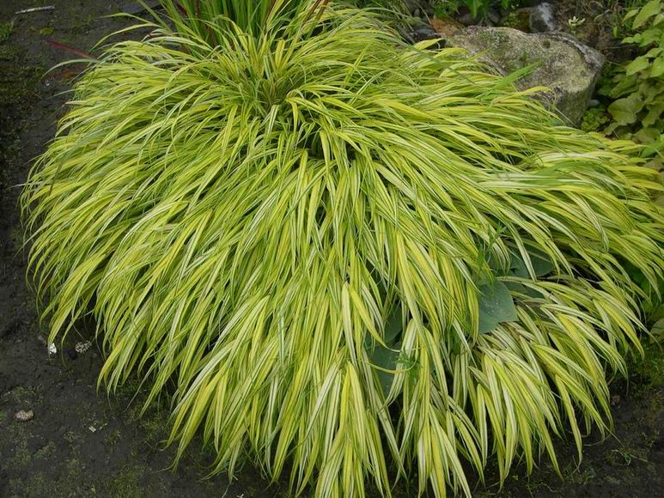  Hakonechloa macra (Japanese Forest Grass) H: 1 to 1.5 feet, July, August | 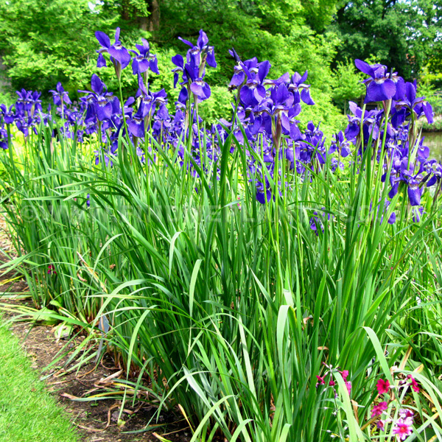  Iris siberica ‘Caesar’s Brother’ (Siberian Iris)  H: 3 to 4 feet, May, Interesting seed pods, excellent foliage with some color in late fall

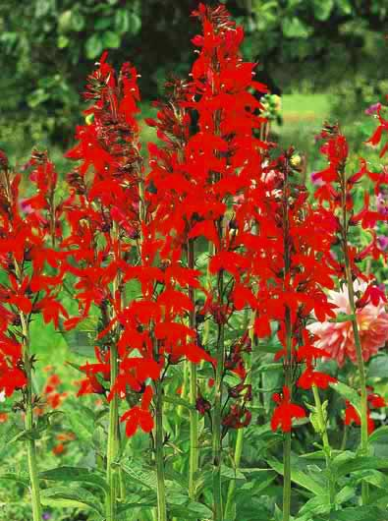  Lobelia cardinalis (Cardinal Flower)  H: 2 to 4 feet, August-September | 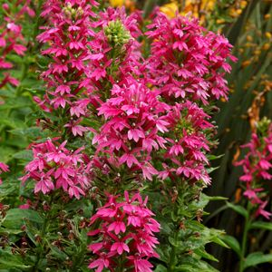  Lobelia ‘Monet Moment’ (Cardinal Flower)  H: 2 to 3 feet, August
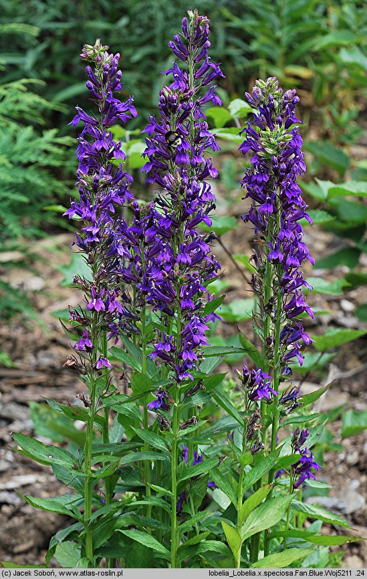  Lobelia ‘Fan Blue’  H: 2 feet, August | 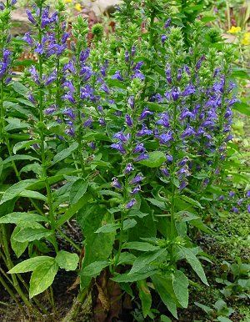  Lobelia siphilitica (Great Blue Lobelia)  H: 2 to 3 feet, August, september

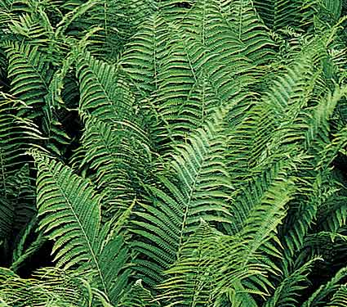  Matteuccia struthiopteris (Ostrich Fern)  H: 3 to 6 feet | 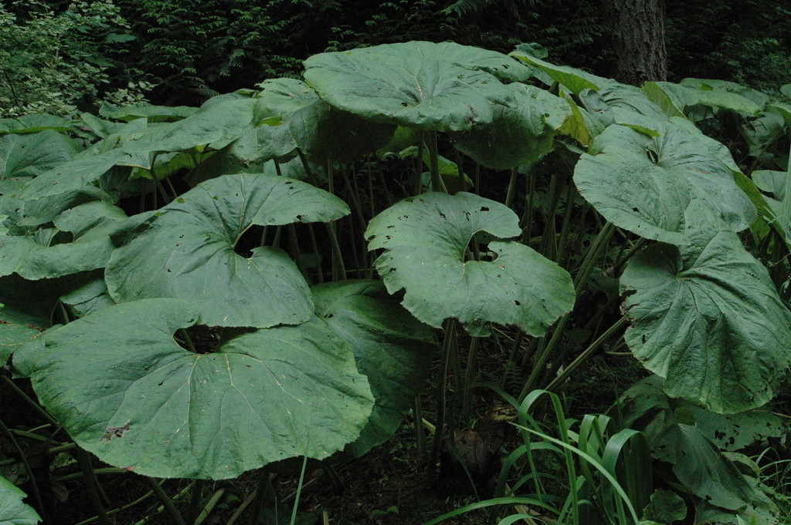  Petasites japonicus (Butterbur)  H: 2 to 3 feet, Early spring, can be aggressive
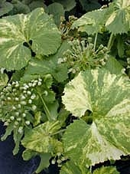  Petasites japonicus var giganteus ‘Nishiki-buki’  H: 2 to 3 feet, Early spring, May revert | 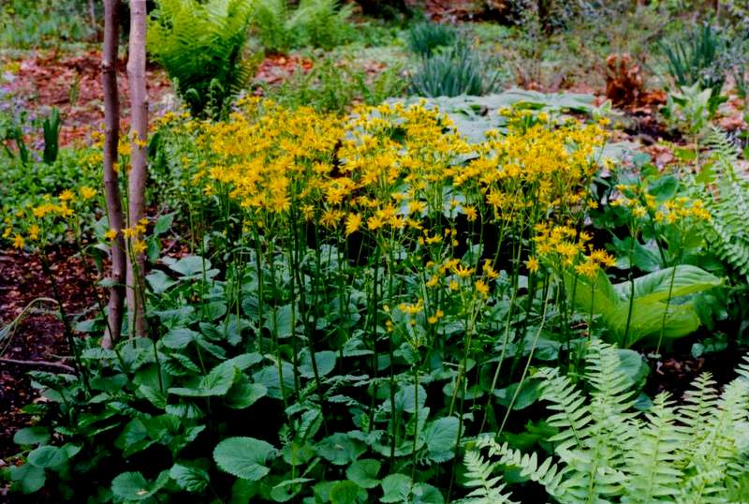  Senecio aureus (Golden Ragwort)  H: 0.5 to 2 feet, Spring

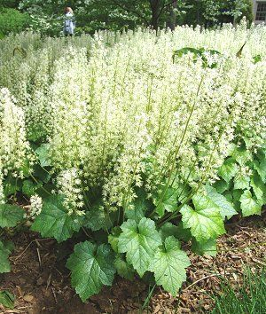  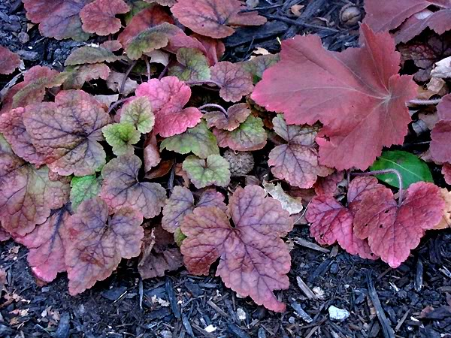  Tiarella cordifolia ‘Brandywine’ (Foam Flower)  H: 0.75 to 1 foot, Spring | 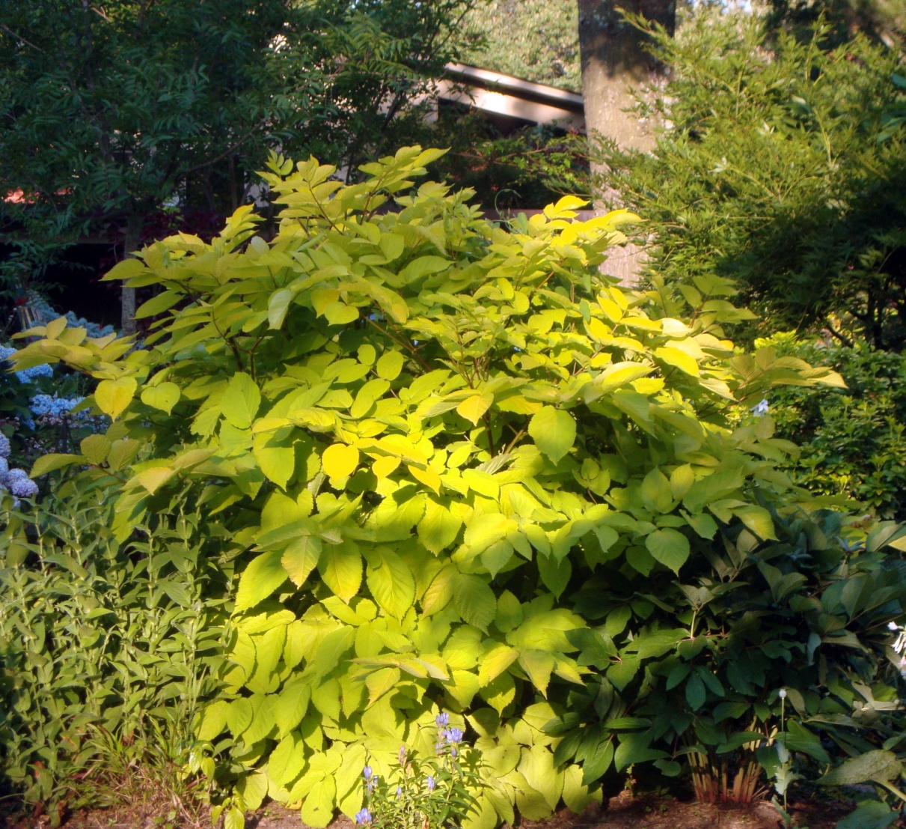  Aralia cordata ‘Sun King’ (Spikenard)  H: 3 to 4 feet, August, September, small purple beries
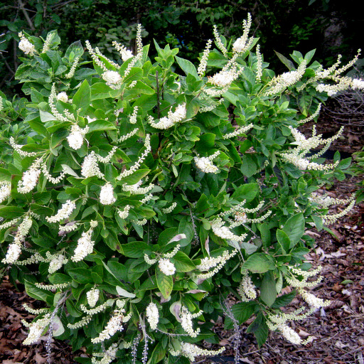  Clethra alnifolia ‘Hummingbird’  H: 2 to 4 feet, July, August, Fall color | 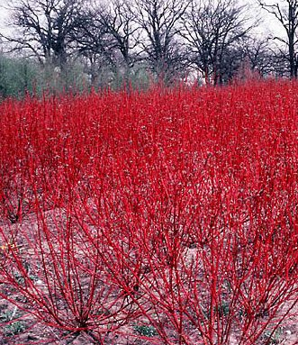  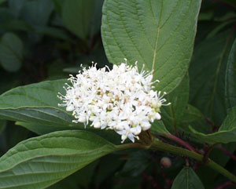  Cornus sericea ‘Baileyi’ (Red Osier Dogwood) H: 6 to 10, May, June, Red stems in winter

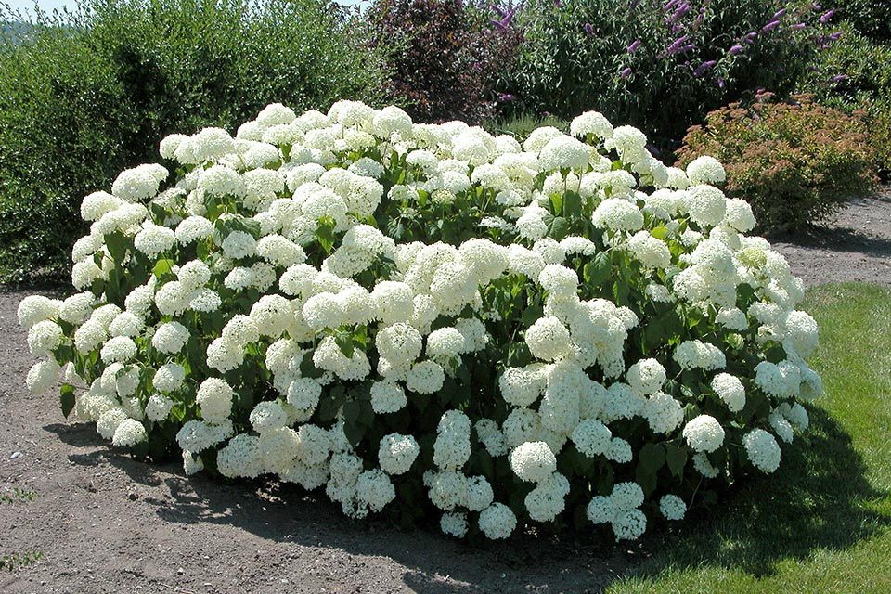  Hydrangea arborescens ‘Annabelle’  H: 3 to 5 feet, July to September, Dried flowers provide winter interest | 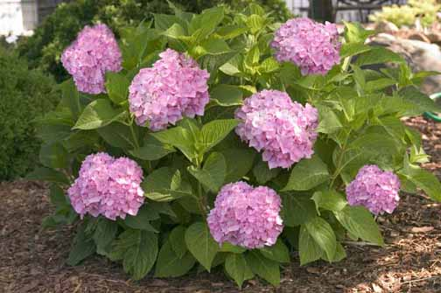  Hydrangea ‘Endless Summer’  H: 2 to 4 feet, July to September
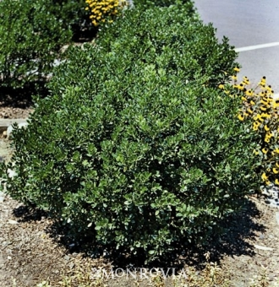  Ilex glabra ‘Compacta’ (Inkberry)  H: 3 to 6 feet, Evergreen, Can be used as boxwood substitute, purple fruit, needs male for pollination | 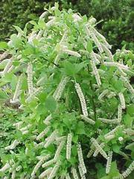  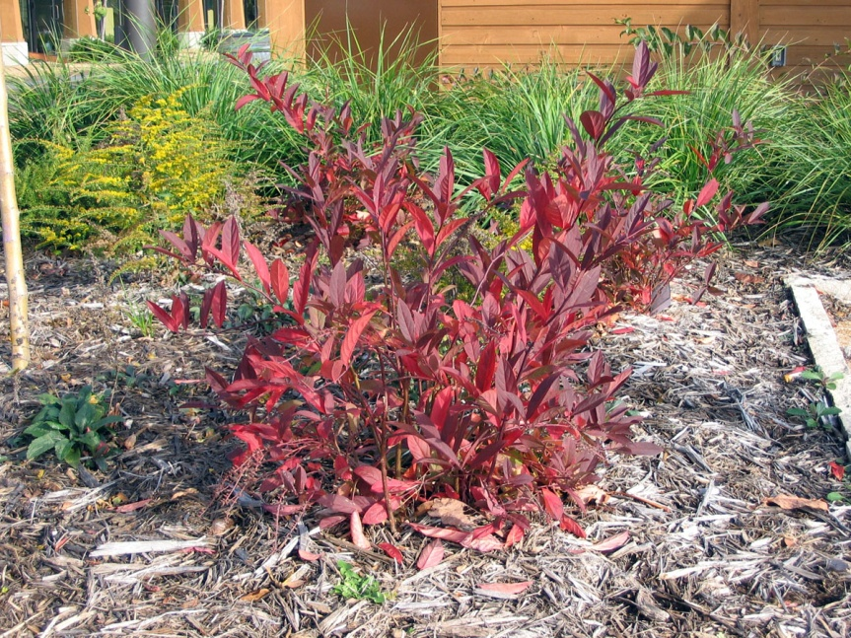  Itea virginica ‘Little Henry ‘Virginia Sweetspire’  H; 2 to 3 feet, June,July, Excellent fall color

