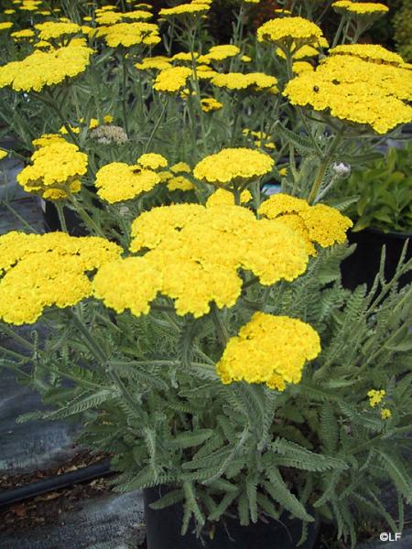  Achillea ‘Moonshine’ (Yarrow)  H: 1 to 2 feet, June-Sept | 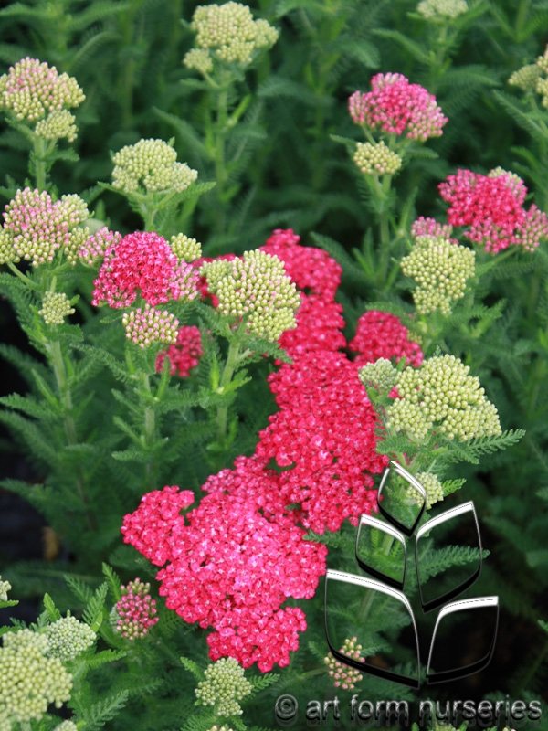  Achillea ‘Saucy Seduction’ (Yarrow)  H: 1.5 to 2 feet, June to August
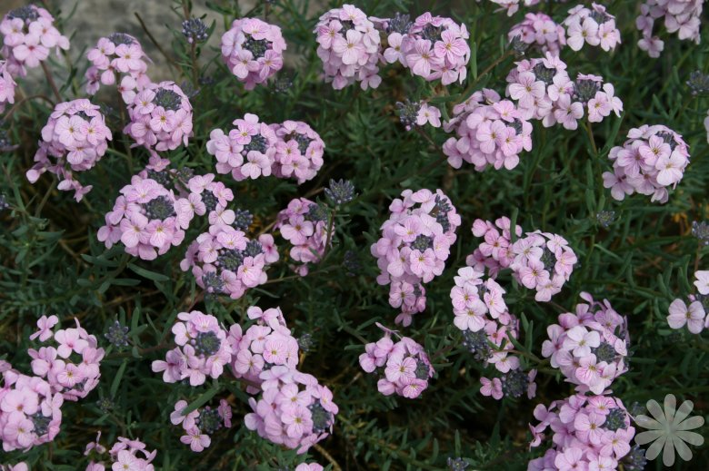  Aethionema schistosum (Stonecress)  H: 10 to 15 inches, early to mid spring | 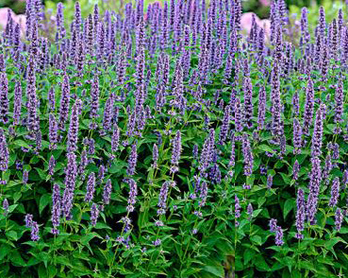  Agastache ‘Blue Fortune’  H: 2 to 3 feet, July-Sept

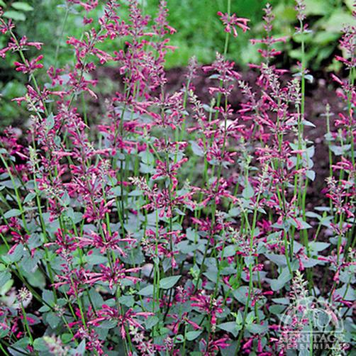  Agastache ‘Bolero’  H: 1.5 feet, mid-summer to early fall | 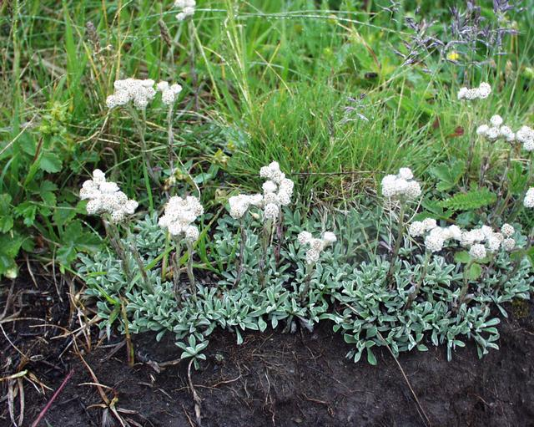  Antennaria dioica (Common Pussytoes)  H: 3 to 9 inches, April to May
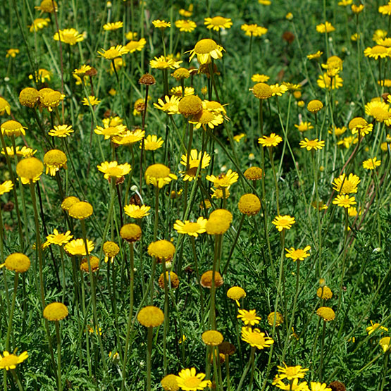  Anthemis tinctoria (Golden Marguerite)  H: 1 to 3 feet, Summer | 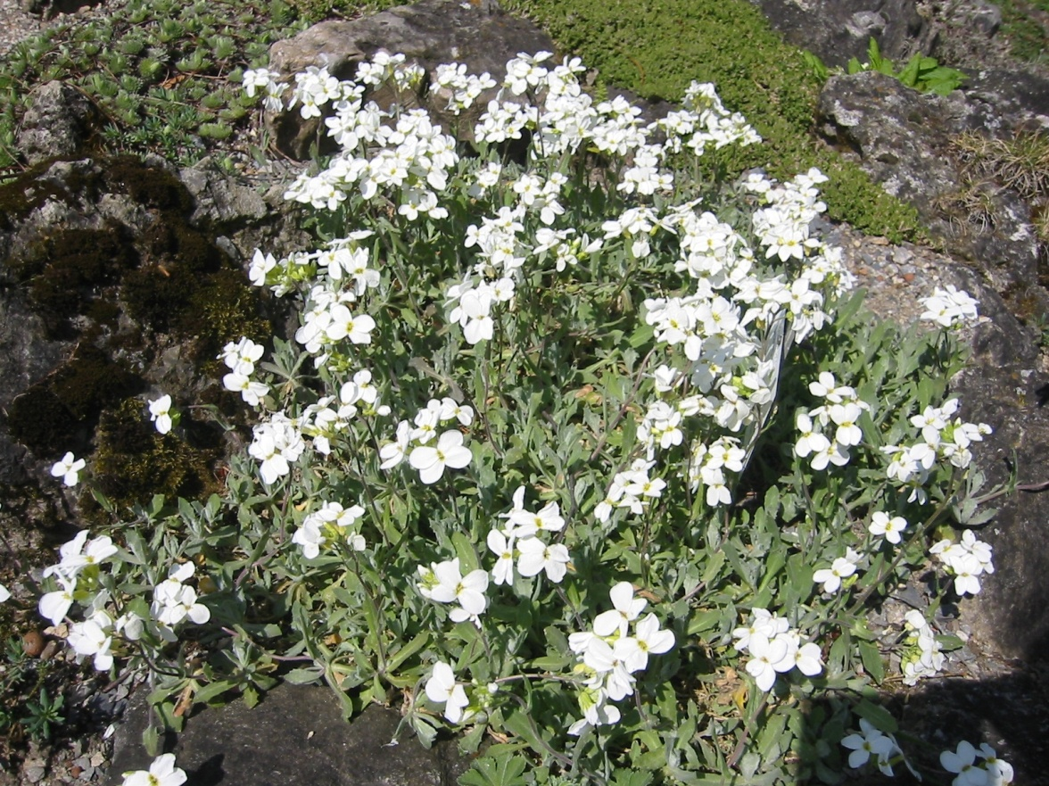  Arabis caucasica (Wall Rock Cress)  H: 0.5 to 1.5, April, May

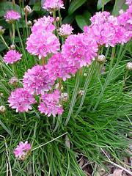  Armeria maritima (Common Thrift)  H: 0.5 to 1, April, May | 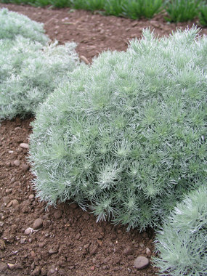  Artemisia ‘Silvermound’(Wormwood)  H: 10 inches
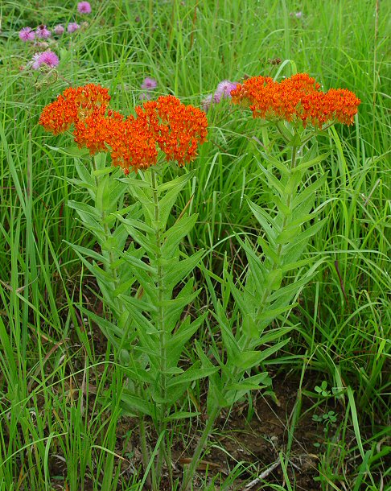  Asclepias tuberosa (Butterfly Weed)  H: 1 to 1.5, June to August, Fall - Seedpods | 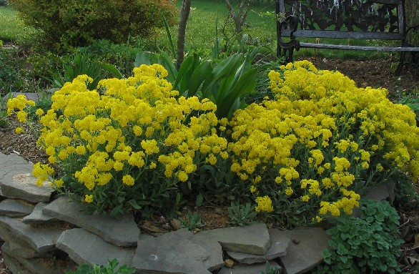  Aurinia saxatilis (Basket of Gold)  H: 0.5 to 1 feet, April, May

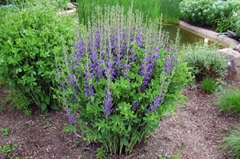  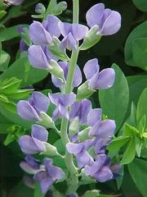  Baptisia australis (False Blue Indigo)  H: 3 to 4 feet, May, June, Seed pods later in summer | 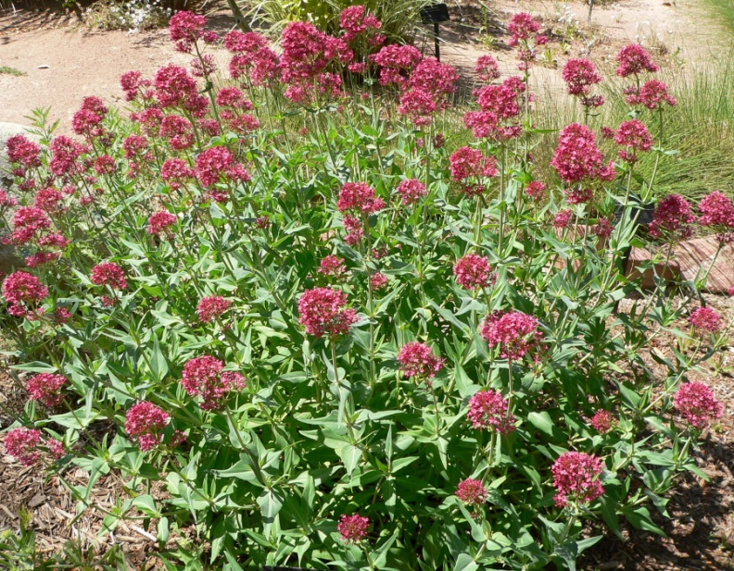  Centranthus ruber (Red Valerian)  H: 1.5 to 3 feet, May,June
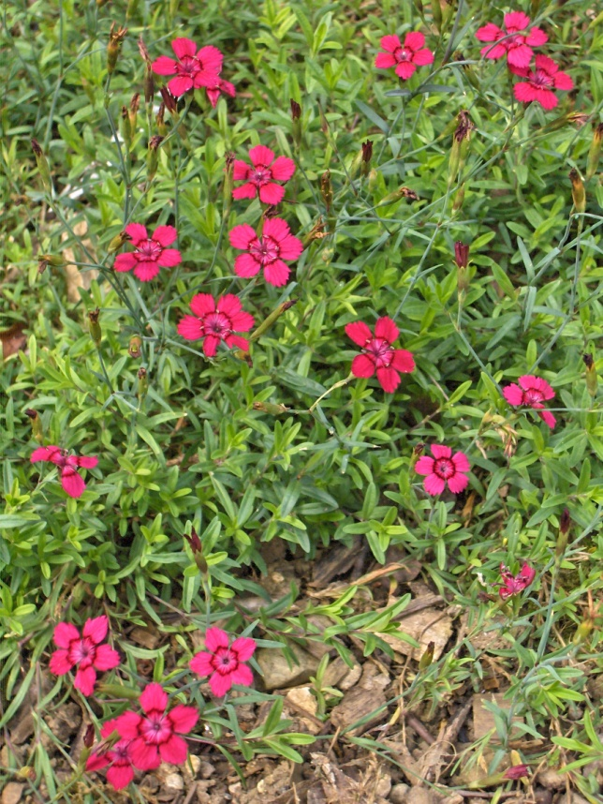  Dianthus deltoides (Maiden Pinks)  H: 0.5 to 1 foot, May, June  Some will rebloom if sheared. | 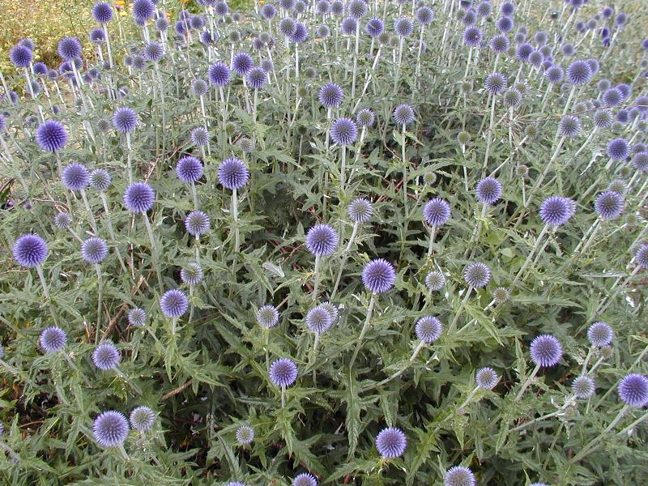  Echinops ritro (Globe Thistle)  H: 3 to 4 feet, July to September

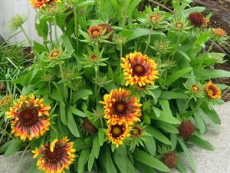  Gaillardia X grandiflora (Blanket Flower)  H: 2 to 3 feet, June to September | 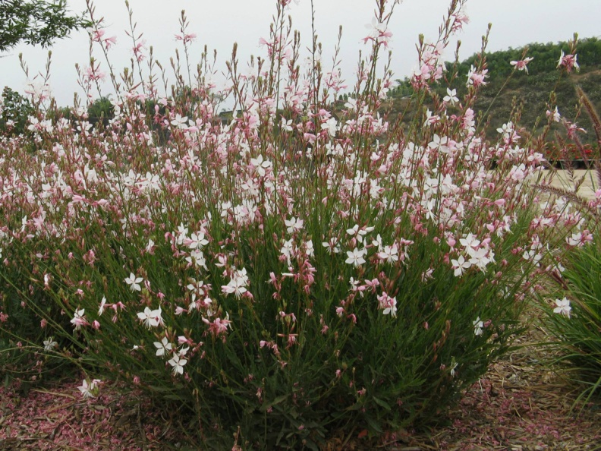  Gaura lindheimeri  H: 3 to 5, August to October
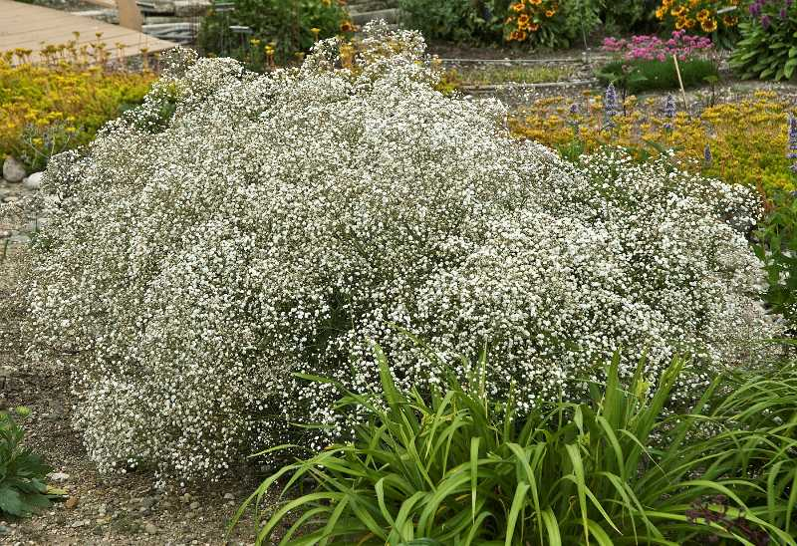  Gypsophila paniculata (Baby’s Breath)  H: 2 to 3 feet, May to August | 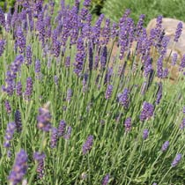  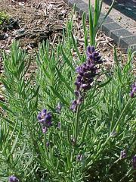  Lavandula angustifolia ‘Hidcote(Common Lavender)  H: 1 to 1.5 feet, June to August

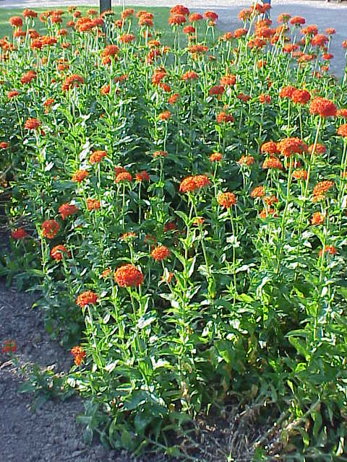  Lychnis chalcedonica (Maltese Cross)  H: 3 feet, Summer | 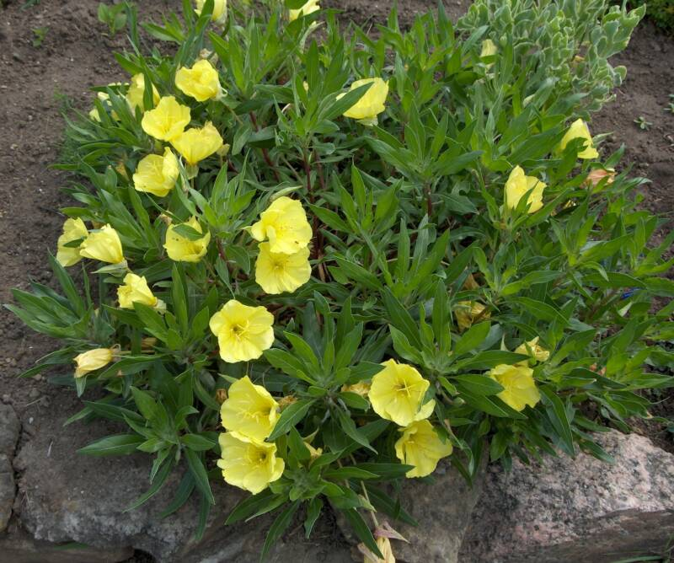  Oenothera macrocarpa (Ozark Sundrops)  H: 0.75 to 1 foot, June to August
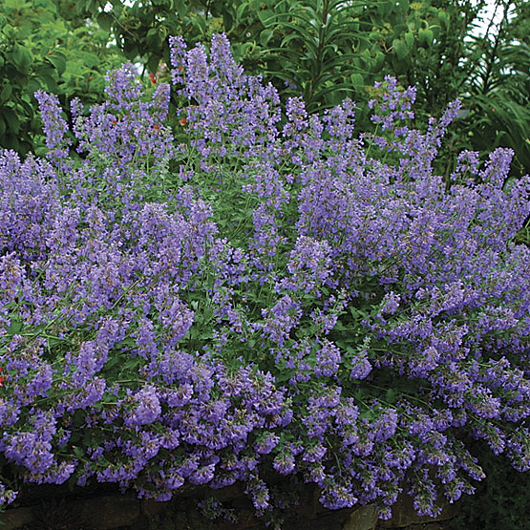  Nepeta ‘Walker’s Low’  H: 2 to 2.5 feet, April and again if cut back | 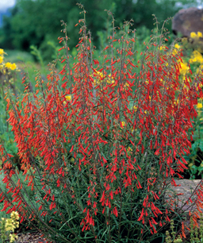  Penstemon spp. (Bearded Tongue)  H: 1.5 to 3 feet, Late Spring

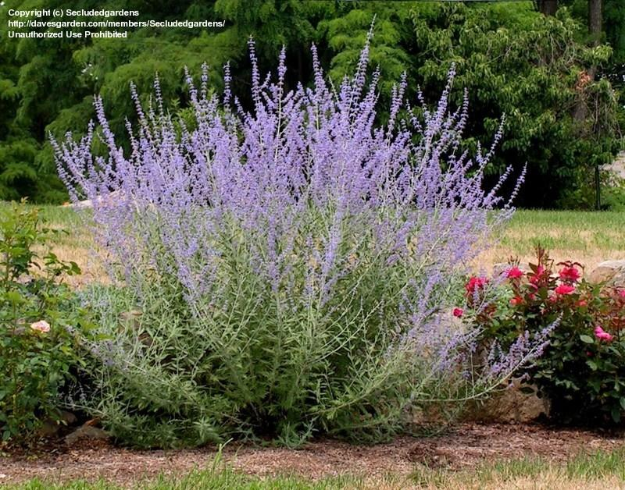  Perovskia atriplicifolia (Russian Sage)  H: 3 to 5 feet, August, September | 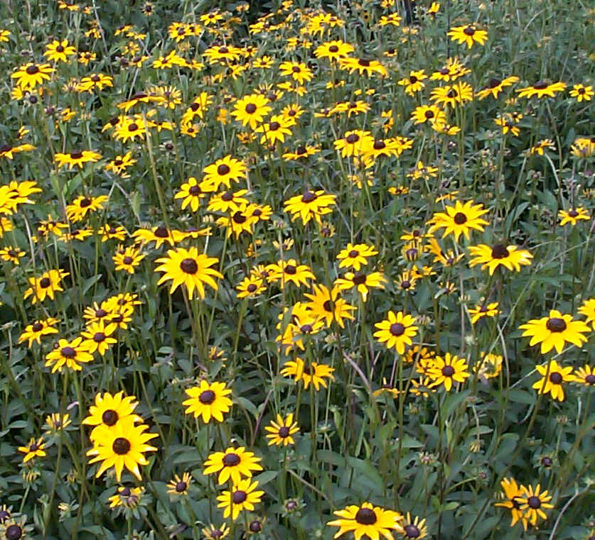  Rudbeckia fulgida fulgida (Orange Coneflower/ Black-eyed Susan)  H: 1 to 2 feet, July to September
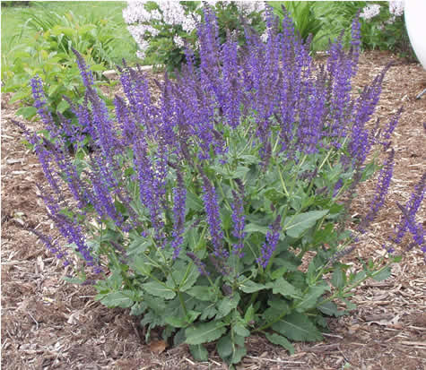  Salvia ‘May Night’  H: 1.5 to 2, May, June and later if dead headed | 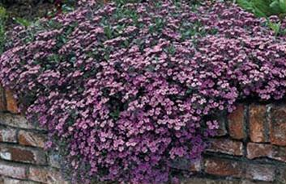  Saponaria ocymoides (Rock Soapwort)  H: 6 to 8 inches, Late spring, early summer

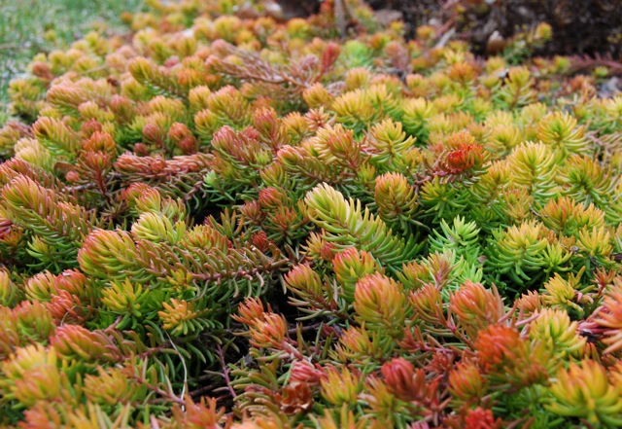  Sedum ‘Agelina’  H: 4 inches, Bloom insignificant, foliage color best in spring and fall | 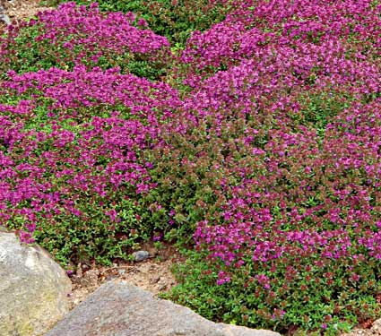  Thymus serpyllum (Creeping Thyme)  H: 3 inches, June, July
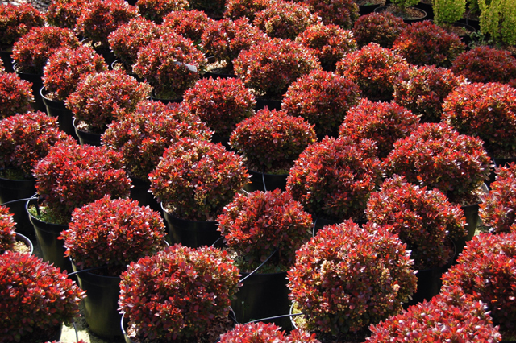  Berberis ‘Bagatelle’ (Barberry)  H: 1 to 1.5 feet | 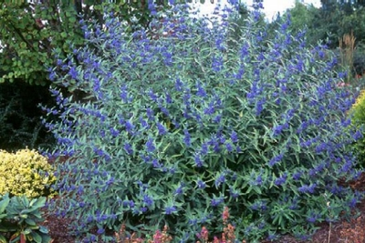  Caryopteris X clandonensis (Blue Beard)  H: 2 to 4 feet, August, September

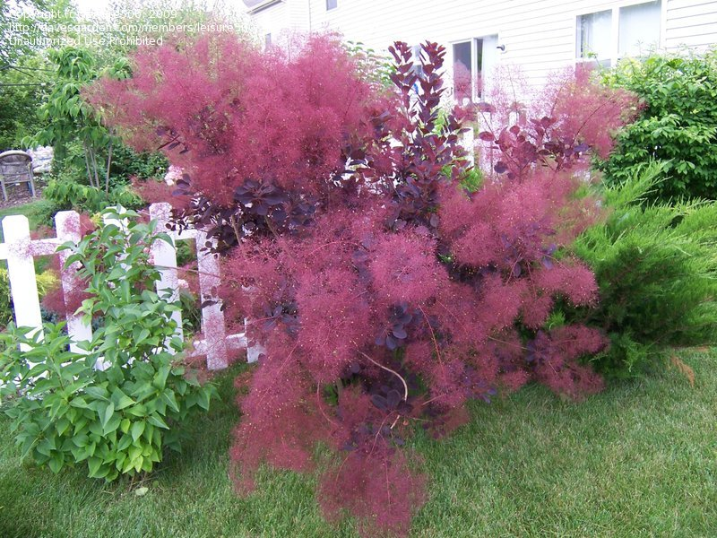  Cotinus coggygria (Smoke Bush)  H: 10 feet, Smoky spent flowers in summer, fall color | 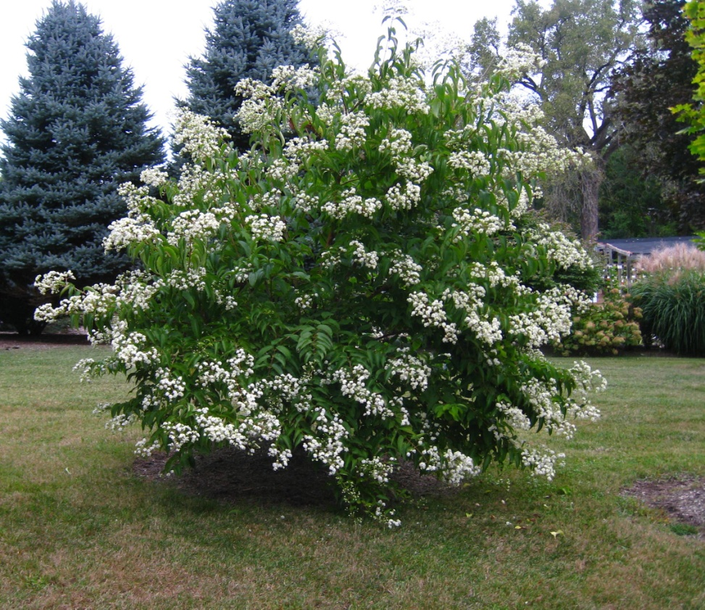  Heptacodium miconioides (Seven Son Flower) H: 15 to 20 feet, September, good seed pods and bark
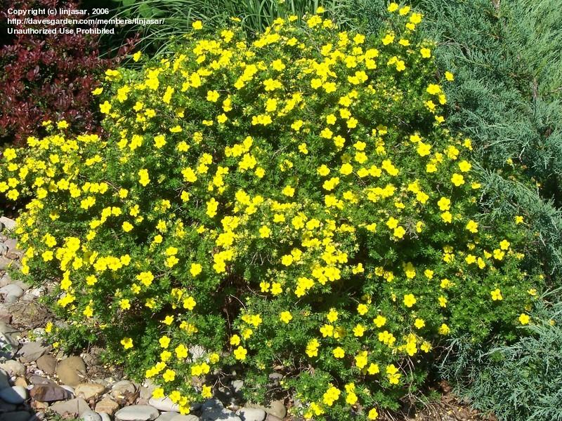  Potentilla fruticosa (Cinquefoil)  H: 2 to 4 feet, June to September | 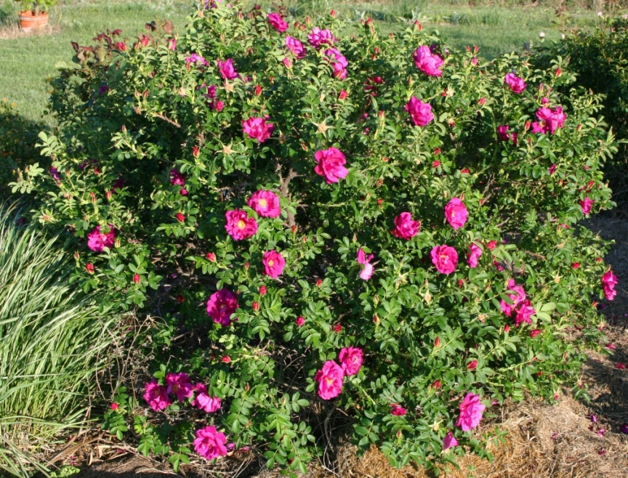  Rosa rugosa ‘Purple Pavement’  H: 3 to 6 feet, June and repeats

