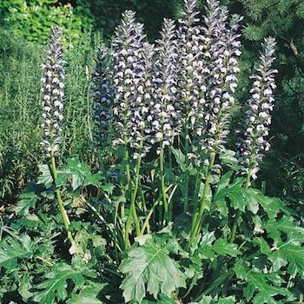  Acanthus spinosus (Bear’s Breeches)  H: 3 – 4 feet, June to August | 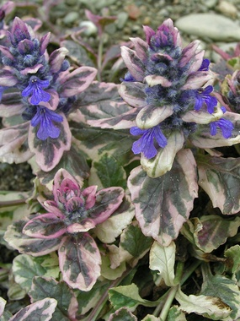  Ajuga reptans ‘Burgundy Glow’  H: 3 – 8 inches, Late spring to early summer
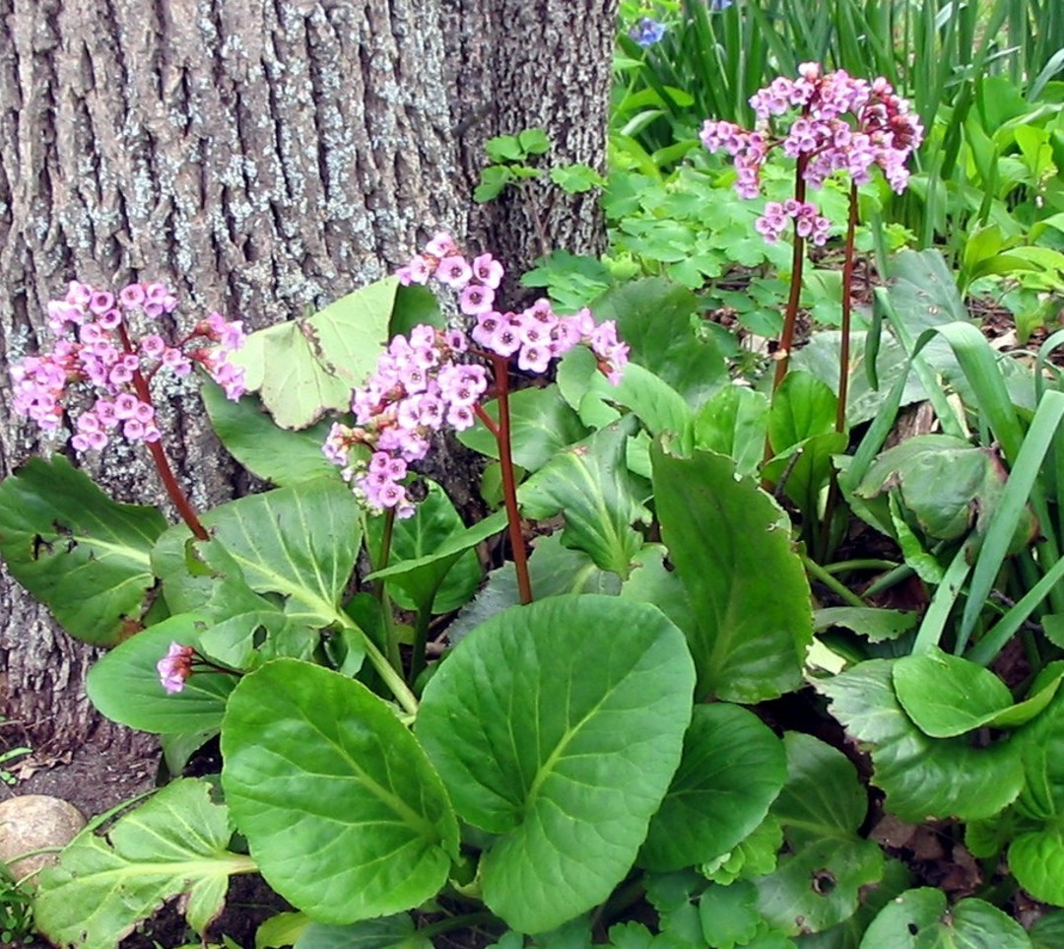  Bergenia cordifolia (Pig Squeak)  H: 1 to 1.5, April, May | 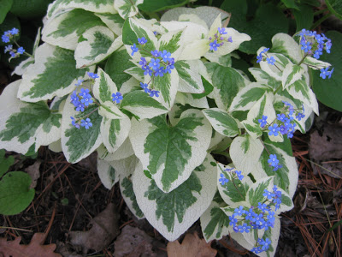  Brunnera variegata  H: 1 to 1.5 feet, April, May

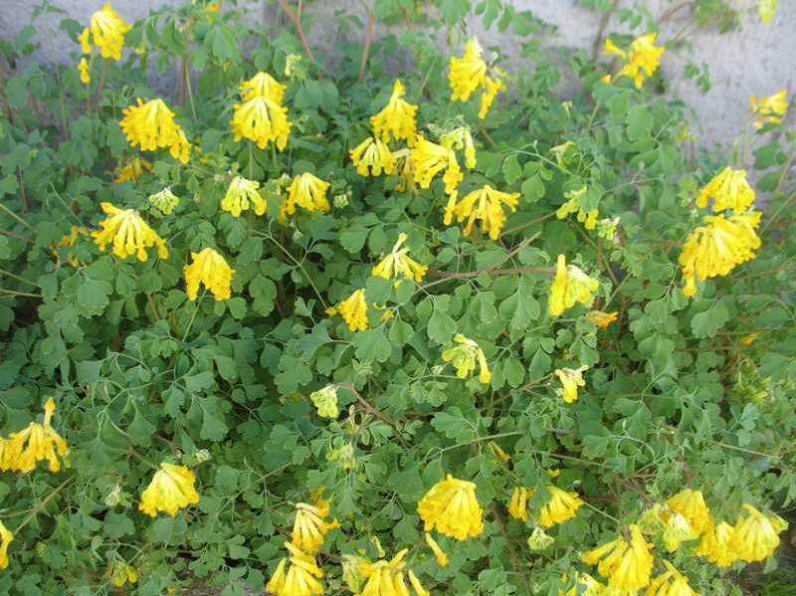  Corydalis lutea  H: 1 to 1.5, May to September | 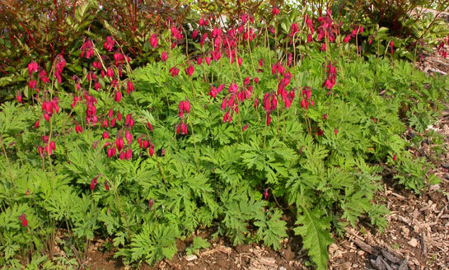  Dicentra formosa (western Bleeding Heart)  H: 6 to 12 inches, late spring
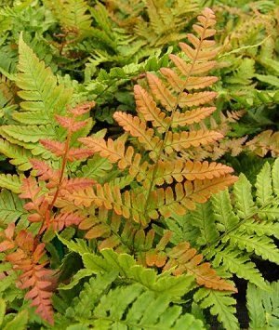  Dryopteris erythrosora, (Autumn Fern)  H: 1.5 to 2.5 feet, peak color in spring | 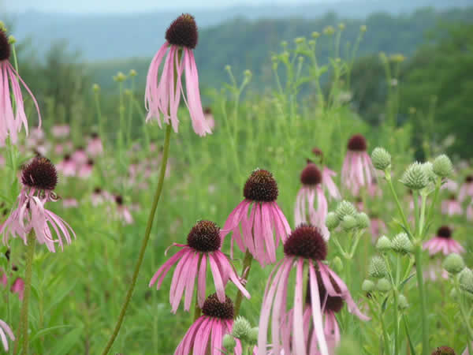  Echinacea pallida ( Pale Purple Coneflower)  H: 2 to 3 feet, June, July

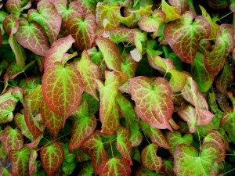  Epimedium X rubrum  H: 0.5 to 1 foot, small red flowers in April | 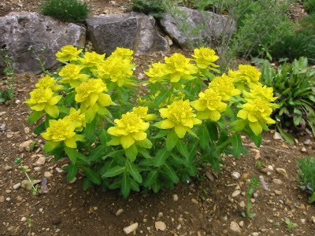  Euphorbia polychroma (Cushion Spurge)  H: 1 to 1.5 feet, April, May
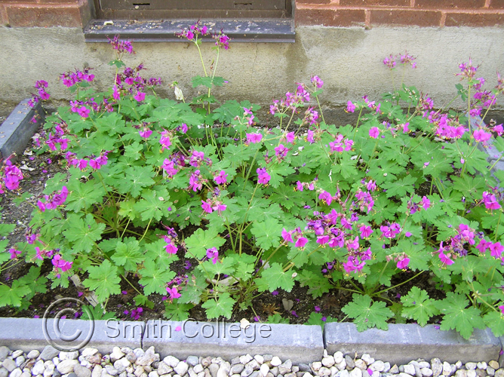  Geranium macrorrhizum (Big Root Geranium) H: 0.75 to 1 foot, April to June | 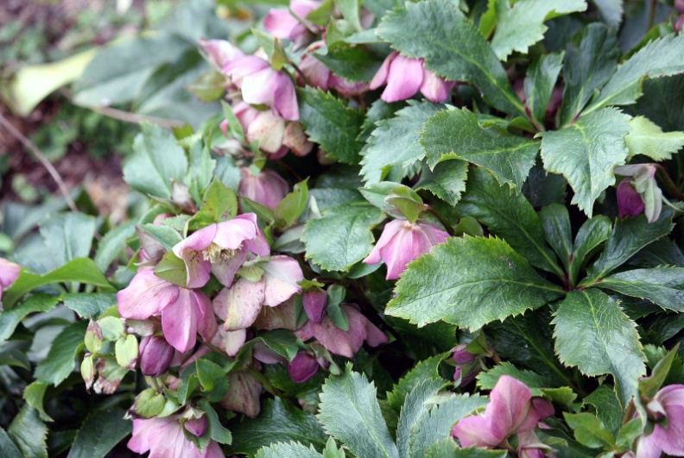  Helleborus  H: 1 to 1.5 feet, March to April

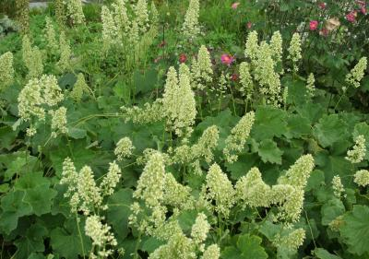  Heuchera villosa ‘Autumn Bride’  H: 1.5 to 3 feet, August, September | 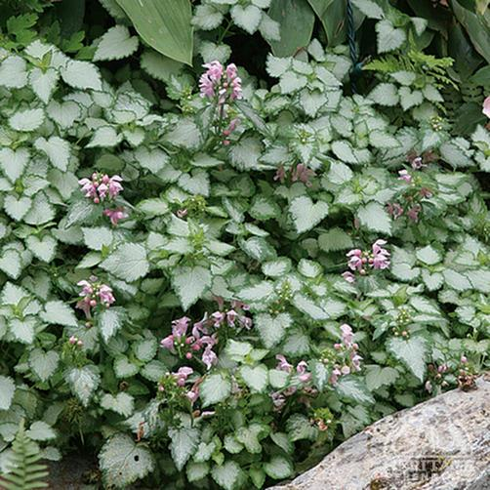  Lamium  H: 6 to 8 inches, Spring and periodically in summer
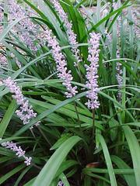  Liriope muscari (Lily Turf)  H: 1 to 1.5 feet, August to September | 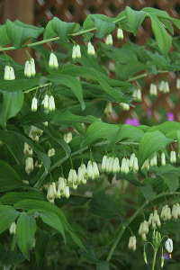  Polygonatum biflorum (Smooth Solomon’s Seal)  H: 1 to 3 feet, April, May

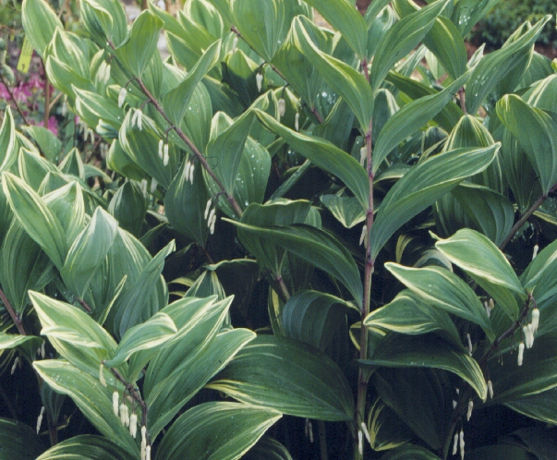  Polygonatum odoratum ‘Variegatum’(Variegated Solomon’s Seal)  H: 2 to 3 feet, April, May | 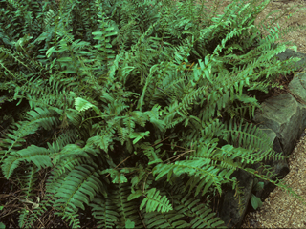  Polystichum acrostichoides (Chrismas Fern)  H: 1 to 2 feet
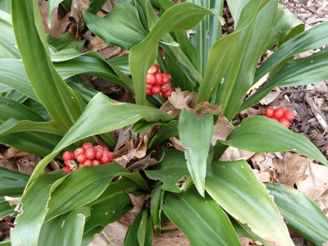  Rohdea japonica (Sacred Lily)  H: 1.5 to 2 feet, Bright berries in fall, Zone 6 | 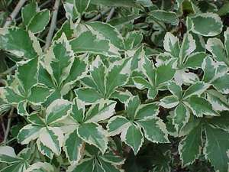  Acanthopanax sieboldianus ‘Variegatus’ (Aralia)  H: 6 to 8 feet, May, June (insignificant)

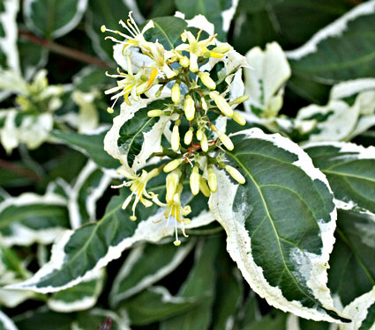  Diervilla ‘Cool Splash’  H: 2 to 3 feet, June, July (insignificant) | 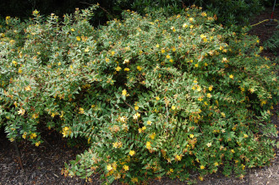  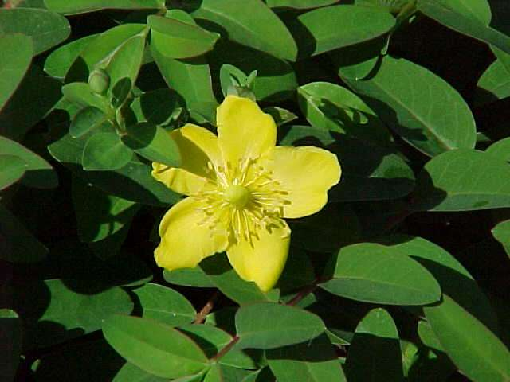  Hypericum beanie (Saint John’s Wort)  H: 2 to 3 feet, July – September, Zone 6
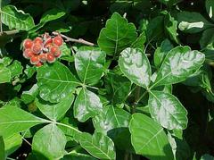  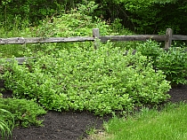  Rhus aromatica (Gro-Lo sumac)  H: 1.5 to 2 feet, April, May (insignificant), Late summer – catkins and berries, fall color | 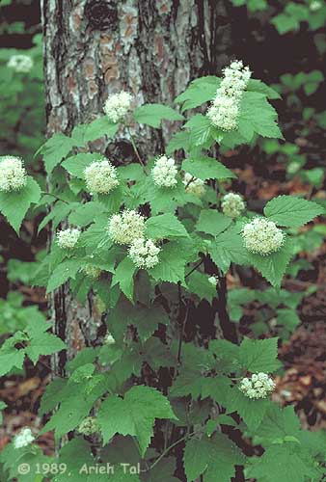  Viburnum acerifolium (Maple leaf viburnum) H: 3 to 6 feet, June, black fruit – September, fall color  Susceptible to the viburnum leaf beetle

