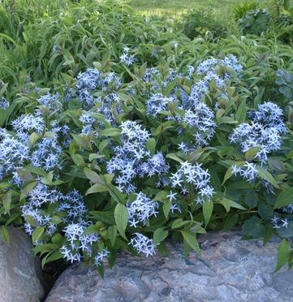  Amsonia tabernaemontana (Blue Star)  H: 2 to 3 feet, May, fall color | 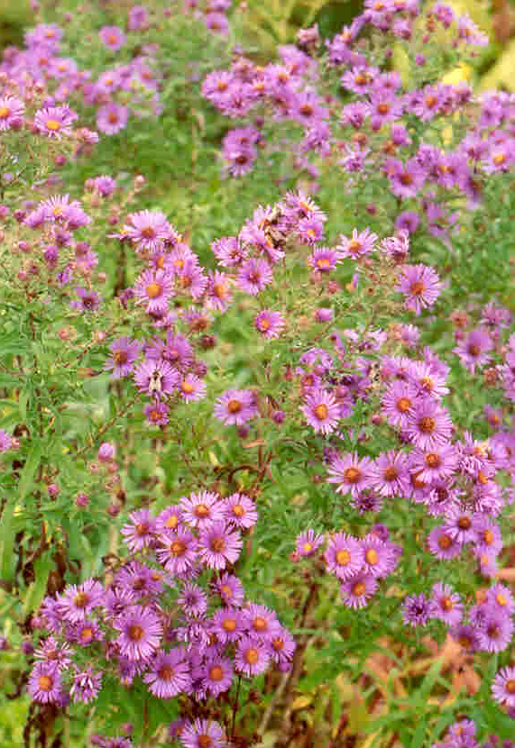  Aster novae-angliae (New England Aster)  H: 3 to 6 feet, August, September
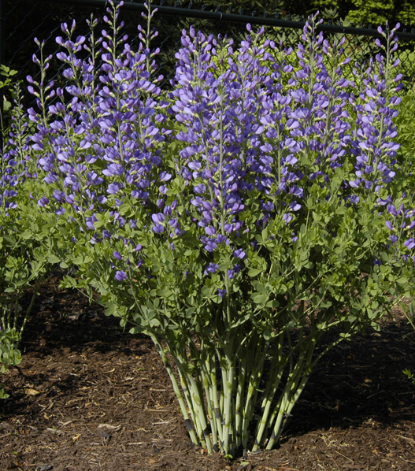  Baptisia australis (Blue False Indigo)  H: 3 to 4 feet, May, June | 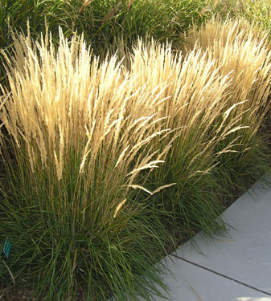  Calamagrostis X acutiflora (Feather Reedgrass)  H: 3 to 5 feet, May into winter

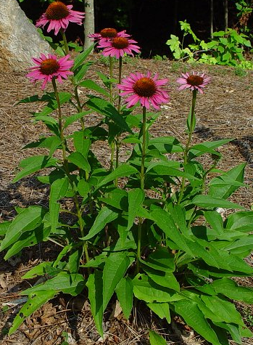  Echinacea purpurea (Purple Coneflower)  H: 2 to 5 feet, July, August | 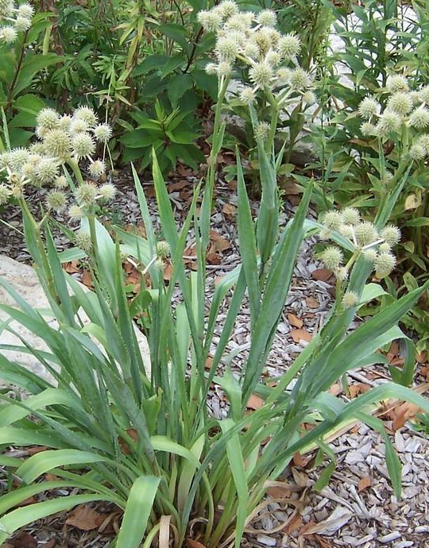  Eryngium yuccifolium (Rattlesnake Master)  H: 4 to 5 feet, July to September
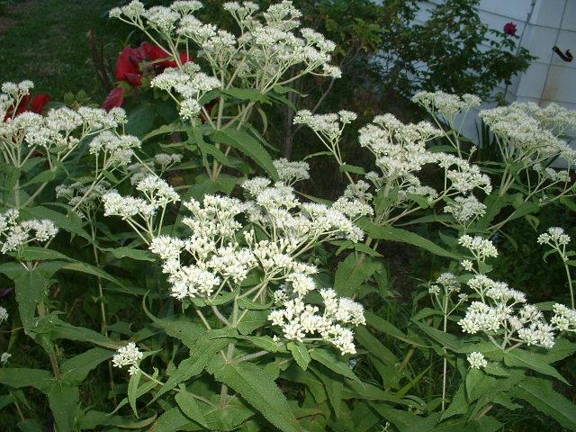  Eupatorium perfoliatum (American Boneset)  H: 4 to 6 feet, July to September | 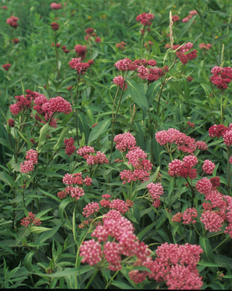  Asclepias incarnata (Swamp Milkweed)  H: 4 to 5 feet, July, August

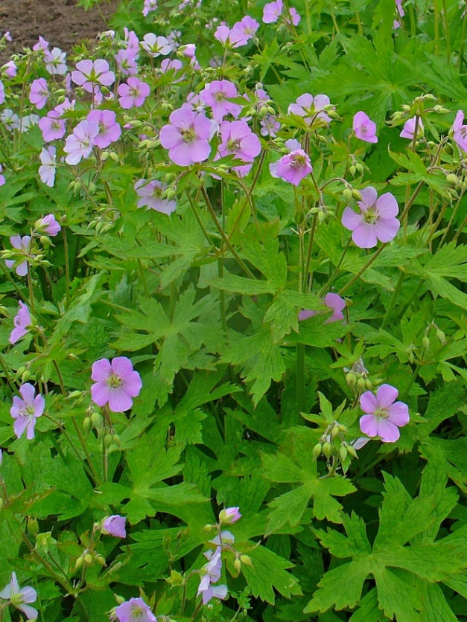  Geranium maculatum (Wild Geranium)  H: 1.5 to 2 feet, April, May | 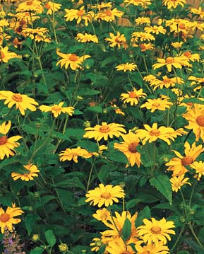  Heliopsis helianthoides (False Sunflower)  H: 3 to 6 feet, June to August
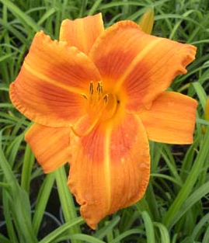  Hemerocallis ‘Rocket City’(Daylily)  H: 3 feet, Midsummer | 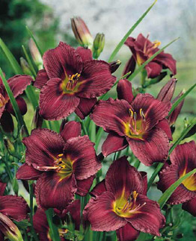  Hemerocallis ‘Little Grapette’ (Daylily)  H: 1.5 feet, Early Summer

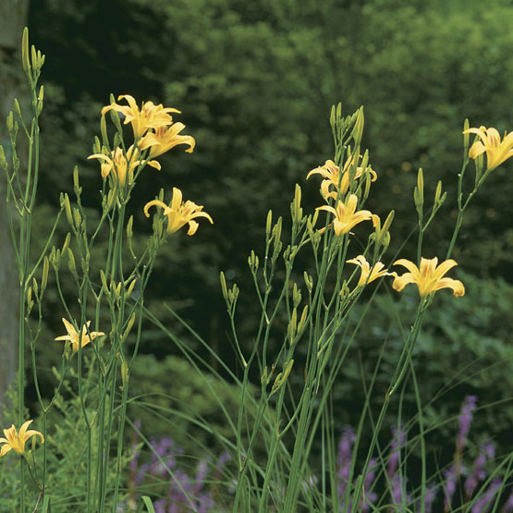  Hemerocallis ‘Autumn Minaret’  H: 5.5 feet, Late Summer | 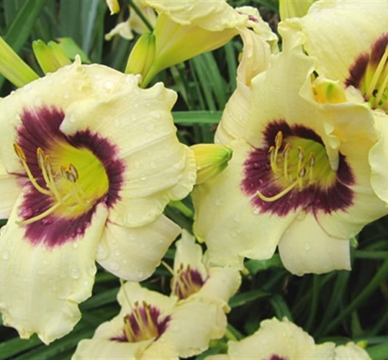  Hemerocallis ‘Pandora’s Box’ (Daylily)  H: 1.5 to 2 feet, June, July
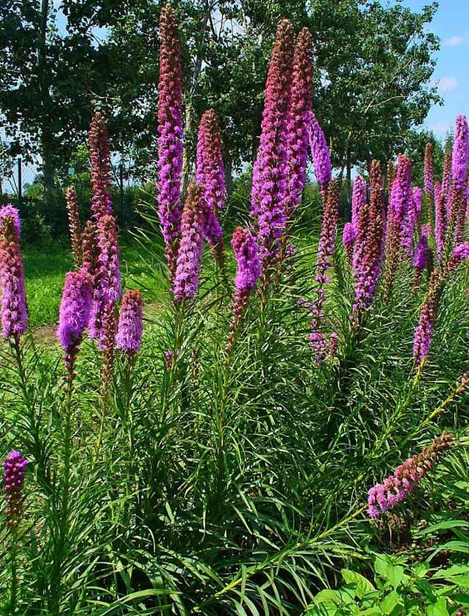  Liatris spicata (Blazing Star, Gay Feather)  H: 2 to 4 feet, July, August | 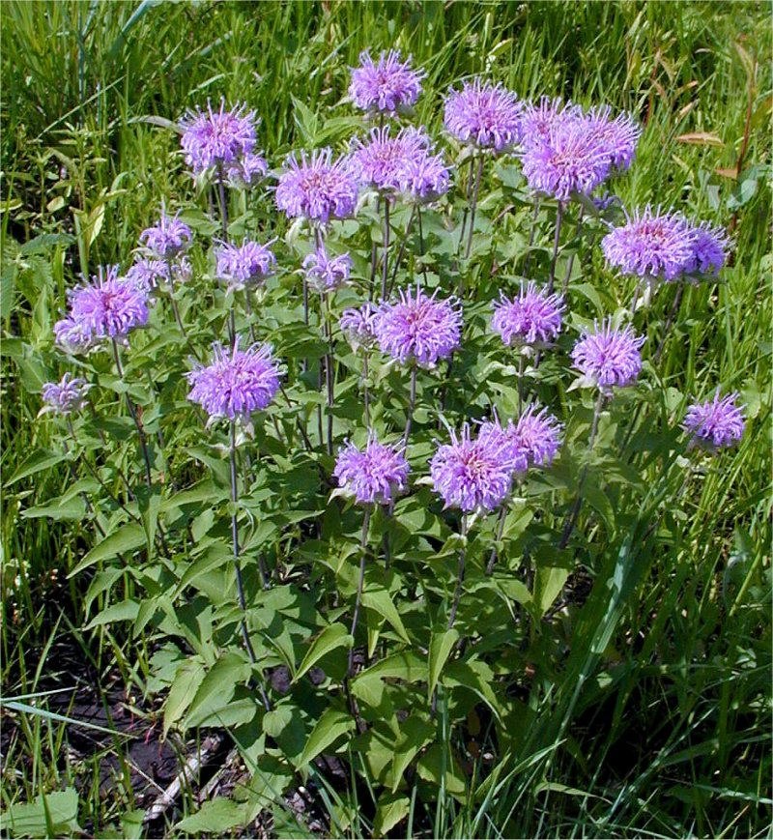  Monarda fistulosa (Wild Bergamot)  H: 2 to 4 feet, July, August

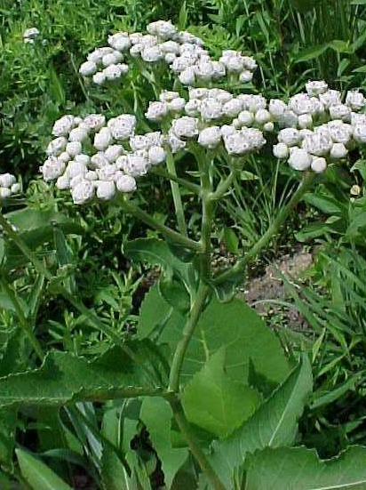  Parthenium integrifolium (Wild Quinine)  H: 2 to 4 feet, June - August | 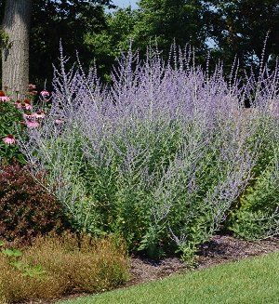  Perovskia atriplicifolia (Russian Sage)  H: 3 to 5 feet, July-September
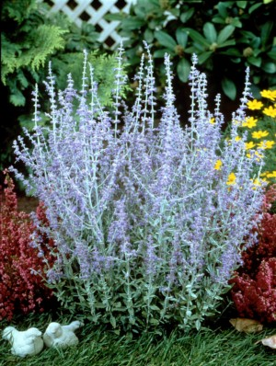  Perovskia atriplicifolia ‘Little Spire’ (Dwarf Russian Sage)  H: 1.5 to 2 feet, July-September | 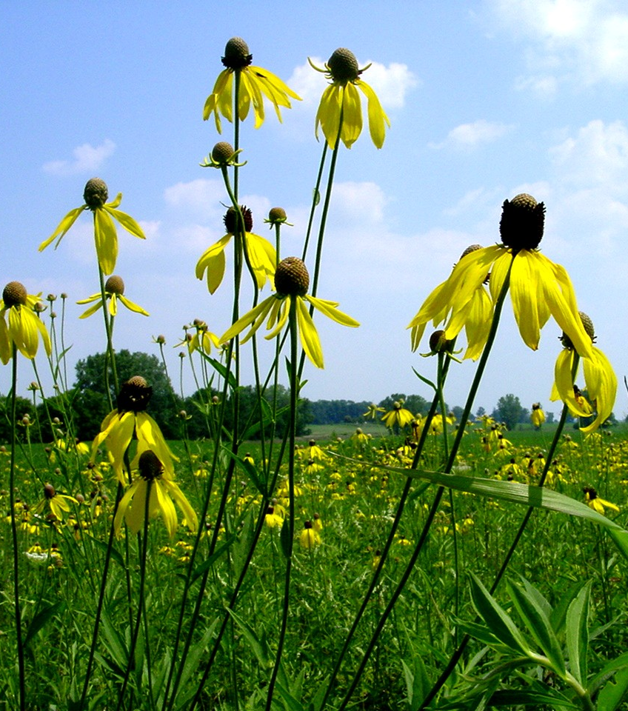  Ratibida pinnata (Gray Headed Coneflower)  H: 3 to 5 feet, July to August

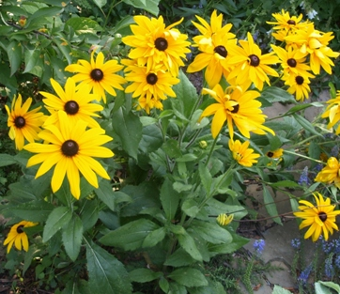  Rudbeckia hirta (Black-eyed Susan)  H: 2 to 3 feet, June to September, Can be short lived | 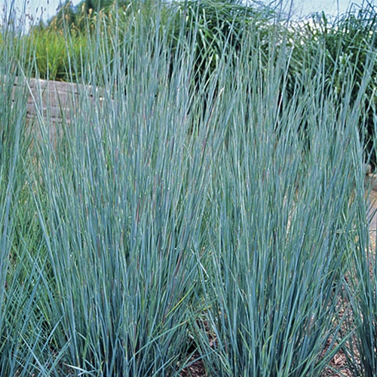  Schizachyrium scoparium (Little Bluestem)  H: 2 to 4 feet, August into winter
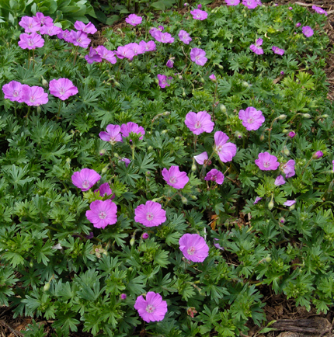  Geranium sanguineum (Bloody Crainsbill)  H: 1 foot, May, June | 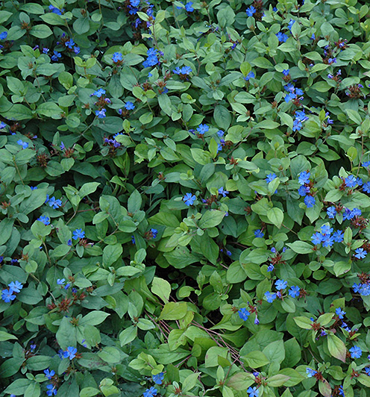  Ceratostigma plumbaginoides (Plumbago)  H: .75 to 1 foot, August, September, fall color

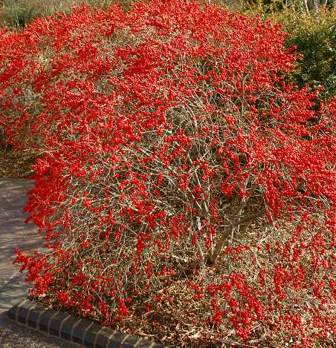  Ilex verticillata ‘Red Sprite’ (Winterberry)  H: 3 feet, June, Red Fruit late summer and fall. Needs a male for pollination. | 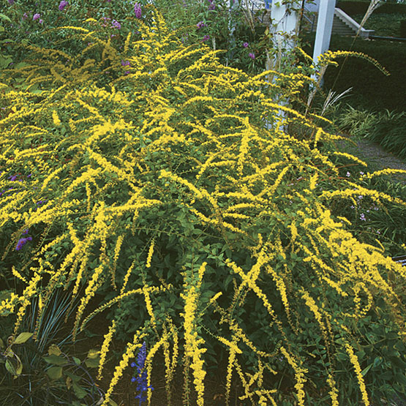  Solidago rugosa ‘Fireworks’  H: 2.5 to 3 feet, September to October
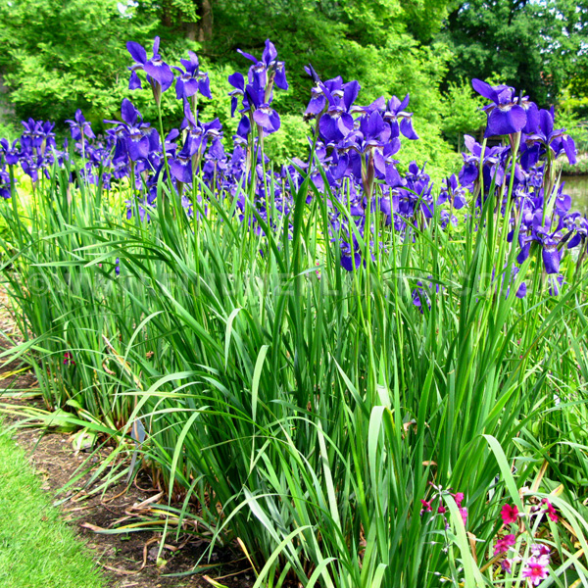  Iris sibirica ‘Caesar’s Brother’ (Siberian Iris)  H: 3 to 4 feet, May, Interesting seed pods, excellent foliage with some color in late fall | 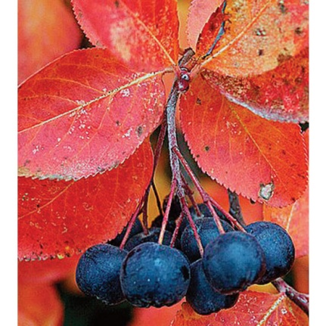  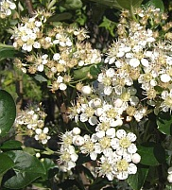  Aronia melanocarpa (Black Chokeberry)  H: 3 to 6 feet, May, Black fruit, fall color

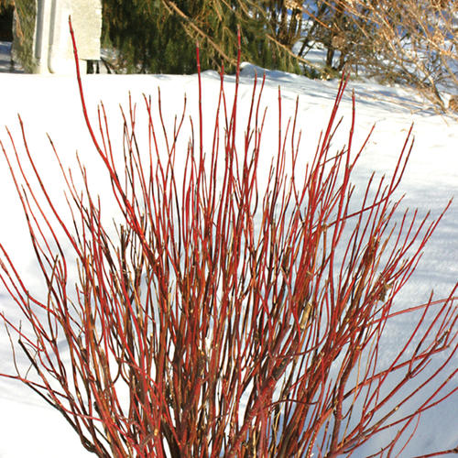  Cornus sericea ‘Arctic Fire’ (Dwarf Red Osier Dogwood)  H: 3 to 4 feet, May, June, Red stems in winter | 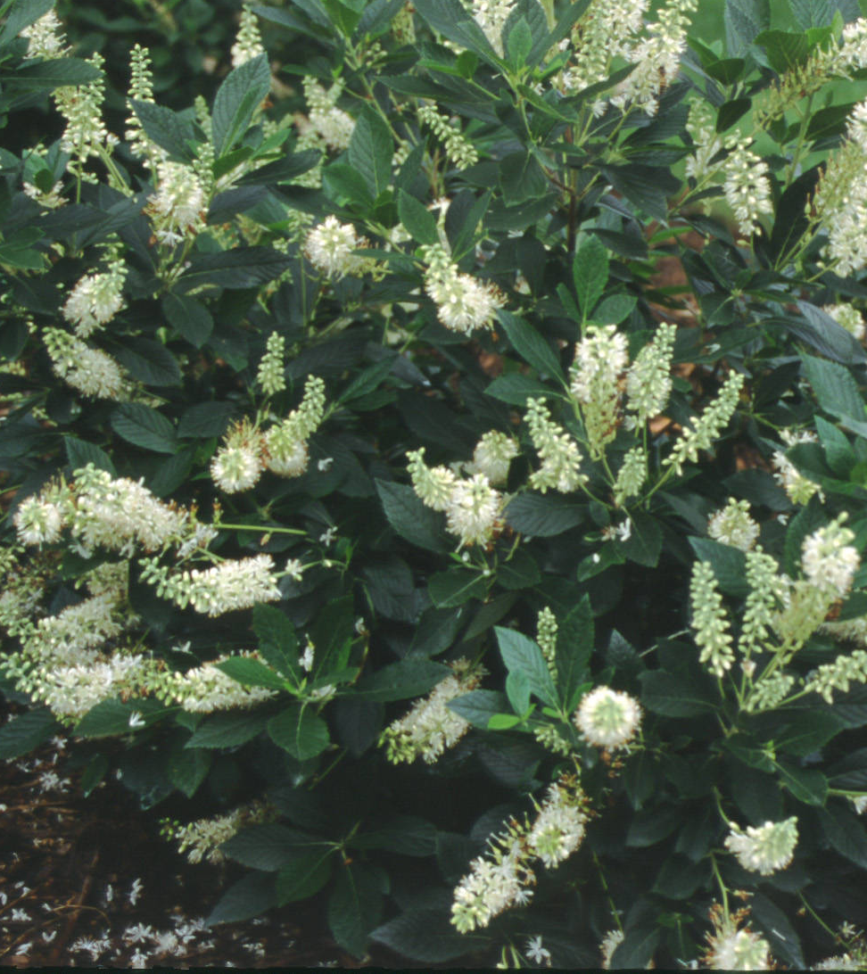  Clethra alnifolia ‘Hummingbird’ (Summersweet)  H: 2 to 4 feet, July, August,  Fall color
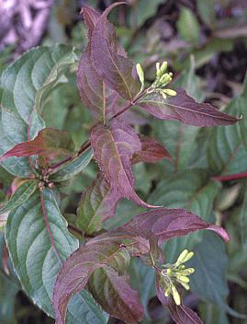  Diervilla lonicera ‘Copper’(Dwarf Bush honeysuckle)  H: 2 to 3 feet, June, suckers, new foliage colorful | 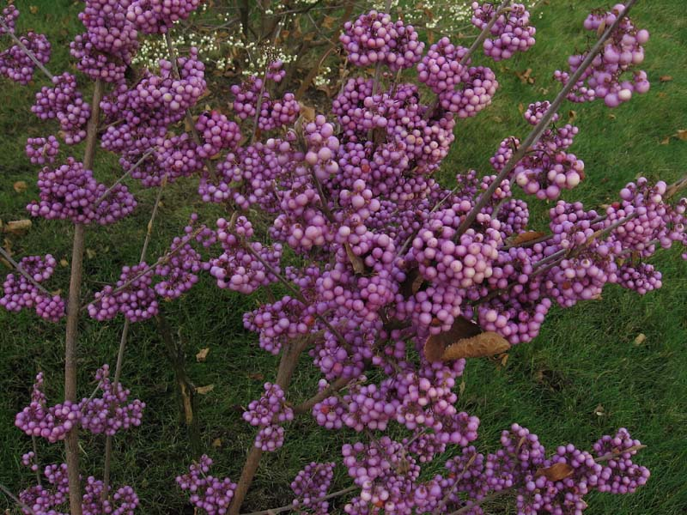  Callicarpa japonica (Beautyberry)  H: 4 feet, June, Fruit late summer into fall, may die back to ground in winter

